## A PROJECT REPORT

**ON**

**“TO DEVELOP STUDENT MANAGEMENT SYTEM WEBSITE BY THE USE OF CLIENT SIDE AND SERVER-SIDE SCRIPTING LANGUAGES WITH DATABASE AND BASIC KNOWLEDGE OF INFORMATION TECHNOLOGY ENGINEERING PROGRAM”**

# Submitted by

|  |  |
| --- | --- |
| Pooja Bhargav | 07 |
| Balpreet Chaudhary | 14 |
| Dhiraj Pawar | 52 |

## UNDER THE GUIDANCE OF

PROF. MR. GOKUL PATIL

**IN PARTIAL FULFILLMENT OF**

**DATABASE MANAGEMENT SYSTEM**

**SAVITRIBAI PHULE PUNE UNIVERSITY**

**GURU GOBIND FOUNDATION, NASHIK**



# DEPARTMENT OF COMPUTER ENGINEERING

|  |  |  |  |  |
| --- | --- | --- | --- | --- |
| **Sr.No** |  |  | **Chapter Name** | **PageNo** |
|  |  |  | **Abstract** | 1 |
|  |  |  | **Introduction** | 2 |
| I | 1.1 |  | Introduction of project | 2 |
|  | 1.2 |  | Problem definition | 3 |
|  | 1.3 |  | Scope of project | 3 |
| II |  |  | **Concepts** | 4 |
|  | 2.1 |  | Basic Concepts of project | 4 |
|  | 2.2 |  | Characteristics of Project | 4 |
|  | 2.3 |  | Architecture of Project | 6 |
|  | 2.4 |  | Basic system design | 6 |
| lll |  |  | **Requirement Analysis** | 7 |
|  | 3.1 |  | Objective of project | 7 |
|  | 3.2 |  | User Requirement | 8 |
|  | 3.3 |  | Hardware and software requirement | 8 |
|  |  | 3.3.1 | Developer Requirement | 8 |
|  | 3.4 |  | Database design | 16 |
| IV |  |  | **Project Lifecycle** | 9 |
|  | 4.1 |  | Feasibility study | 9 |
|  | 4.2 |  | Project work schedule | 11 |
|  | 4.3 |  | Time Required for the various stages for  Project | 13 |
| V |  |  | **System Design and modeling** | 16 |
|  | 5.1 |  | Database and modeling | 16 |

|  |  |  |  |  |
| --- | --- | --- | --- | --- |
|  |  | 5.5.1 | Concurrency and recon currency issue | 12 |
|  | 5.2 |  | UML Diagram | 13 |
|  |  | 5.2.1 | Use Case diagram | 14 |
|  |  | 5.2.2 | Data Flow diagram | 14 |
|  |  | 5.2.3 | Activity diagram | 15 |
|  |  | 5.2.4 | Sequence diagram | 17 |
|  |  | 5.2.5 | Class Diagram | 17 |
|  |  | 5.2.6 | ER Diagram | 13 |
| VI |  |  | **System Implementation** | 17 |
|  | 6.1 |  | Structure of project | 18 |
|  | 6.2 |  | Architecture model of the system | 18 |
|  |  | 6.2.1 | Front End and Back End | 17 |
|  | 6.3 |  | Procedural model of the system | 16 |
|  | 6.4 |  | Data Structure and API used | 17 |
|  |  | 6.4.1 | Technical Specification | 18 |
| VII |  |  | **Testing and Result** | 19 |
|  |  | 7.1 | Testing | 19 |
|  |  | 7.2 | Testing plane | 19 |
|  |  | 7.3 | Unit Testing | 19 |
|  |  | 7.4 | Integration Testing | 19 |
|  |  | 7.5 | Automation Testing | 19 |
| VIII |  |  | **Coding** | 21-60 |
| IX |  |  | **Evolution of project** | 61 |
|  | 9.1 |  | Memory Analysis | 61 |

|  |  |  |  |  |
| --- | --- | --- | --- | --- |
|  | 9.2 |  | Platform | 62 |
|  | 9.3 |  | Performance | 63 |
|  | 9.4 |  | Advantage and Disadvantages | 65 |
|  | 9.5 |  | Future Scope | 66 |
|  | 9.6 |  | Cost Estimation | 66 |
|  | 9.7 |  | User Manual | 66 |
| X |  |  | **Flow of Project** | 67 |
|  |  |  | Screenshot | 67 |
|  |  |  | Conclusion | 67 |
|  |  |  | **Biography** | 68 |

**Abstract**

Student Information Management System (SIMS) provides a simple interface for maintenance of student information. It can be used by educational institutes or colleges to maintain the records of students easily. The creation and management of accurate, up-to-date information regarding a students’ academic career is critically important in the university as well as colleges. Student information system deals with all kind of student details, academic related reports, college details, course details, curriculum, batch details, placement details and other resource related details too. It tracks all the details of a student from the day one to the end of the course which can be used for all reporting purpose, tracking of attendance, progress in the course, completed semesters, years, coming semester year curriculum details, exam details, project or any other assignment details, final exam result and all these will be available through a secure, online interface embedded in the college’s website. It will also have faculty details, batch execution details, students’ details in all aspects, the various academic notifications to the staff and students updated by the college administration. It also facilitate us explore all the activities happening in the college, Different reports and Queries can be generated based on vast options related to students, batch, course, faculty, exams, semesters,

**ChapterNo1**

# INTRODUCTION

## Introduction of Project

The objective of **Student Management System** is to allow the administrator of any organization to edit and find out the personal details of a student and allows the student to keep up to date his profile .It’ll also facilitate keeping all the records of students, such as their id, name, mailing address, phone number, DOB etc. So all the information about an student will be available in a few seconds. Overall, it’ll make Student Information Management an easier job for the administrator and the student of any organization. The main purpose of this SRS document is to illustrate the requirements of the project Student information System and is intended to help any organization to maintain and manage its student’s personal data. Presently, the Management for the students is done manually. Initially the student section has to collect all student registration details branch wise and year wise. These details include name, roll no. , branch, year, list of subjects registered for exam. The administrator need to count the total number students registered.

Then he needs to select the Exam rooms and divide the students among those classes and subject. After dividing the classes, he need to prepare students list for each based on the exam. He also needs to prepare the Management list for each room based upon the count. All this work need to be done for each Student and for each branch and year. This is very tedious work and there are many chances for mistakes to occur due to manual work. The "**student Management system**" atomizes the existing system of assigning Management. When a student registers for an student, this system stores student registration details (name, roll no. , branch, year & semester, subjects, Email ID) in the database depending on the branch, year & semester. These details can be efficiently used whenever required. The automation of the system will help the organization in proper maintenance of the record, less manpower, less man-days, less cost, proper & accurate functioning.

## Problem Statement:-

Most of the institutions are becoming unwilling to centralized student system day by day. One of the major causes is that with the increasing number of students, courses and departments ,it becomes almost unmanageable to allocate proper Student Management.

It is quite difficult to properly allocate the Management among a large number of students whenever the students are from different subjects. We have to follow some pre conditions for proper allocation of Student Management. The best use of the Management should be confirmed. To get rid of these hassles, some institutions encourage decentralized the Student system instead of the centralize Student system. They offer the course teachers to arrange the exams individually for the students of the same course.

But it is very hard for a course teacher to manage quality student while conducting Student this way. For maintaining central student some institutions offer one room for one Student to get rid of this hassle of preparing a Management plan.

As a result the quality of student as well as student becomes questionable for lots of the educational institutions. This Student Management and room assignment. Our research objective is to find out the solution of Student Management or room assigning problems to prevent cheating in exams.

## Scope of Project:-

The scope of the project is the system on which the software is installed, i.e. the project is developed as a web based application, and it will work for a particular institute. Mostly students are facing many problem for finding the Student Management and their Management respectively the scope of our System is to assign or deallocate staff according to their assign exam.. Our project scope is up to student.

**ChapterNo2**

# Concept

# Basic Concepts of projects:-

Student Management is specially design for automation of Student system. This system deals with the Management process of Student online instead of manually. This application will be used for the automatic Management of Management on the basis of number of students, number of classes and number of benches in a class also respected staff. While an extensive body of research exists regarding the delivery of course knowledge and material, much less attention has been paid to the performance effect of Management location within a classroom. This study examines the effects of Management location and Management type on student performance.

# 2.2.1The Module:-

A collection of data designed to be used by different people is called a database. It is a collection interrelated data stored together with controlled redundancy to serve one or more applications in an optional fashion. The data is stored in such a fashion that it is independent of the programs of people using the data. A common and controlled approach is used in adding new data and modifying and retrieving existing data within the database

1. Login Module
2. Teacher Management Module
3. Student Management Module
4. Subject Management Module
5. Class Management Module
6. Student Management Module
7. User Management Module
8. **Login Module:-**

In Login module user needs to enter username and password. Our system will check whether he or she entered a correct on or not , also in our system there are 2 module , one is for user ie staff and another is one for Student arrangement coordinators ,ie Admin login.

1. **Teacher Management Module:-**

In teacher management module Student arrangement coordinator can Add or remove teacher which is assign for that particular Student , Suppose for PHP Student G.J.Solanke is allocated as a Student Management coordinator then admin can add **G.J.Solanke** as a Teacher in our system

1. **Student Management Module:-**

In Student management module admin can add student which are assign for that Student Management. Admin can add and remove specific student also using ID of that particular student.

1. **Subject Management Module:-**

In this module admin can add or remove Subject of Student . he needs to select teacher name also if he want to add Subject.

1. **Class Management:-**

In this Module admin can add Class for that particular Student , Supposed there is a Student called PHP then admin can add a special Class for that Student , also he needs to select a Class type.

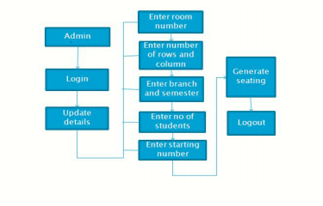

1. **Student Management :-**

This is very import module , we can say this is backbone of all above module . Here user will add all Student details like time of Student , which Student , which class , which faculty ect. all details admin will add here.

1. **User management Module:-**

Last but not least in this module Admin will add user or he/she can delete user also . for adding a user admin will assign id pass for that user, also admin can modify privileges for that user . like adding / removing Class , Adding / removing student ect.

# Characteristics of project:-

* It tracks all the information of Management, In charge.
* Roll Number ect. Manage the information of Management.
* Shows the information and description of the **Exam**, Student.
* All the fields such as **Exam**, Student, Rooms are validated and does not take invalid values.

# Chapter No 3

# REQUIREMENT ANALYSIS

## Objective of Project:-

The main purpose of this project is to manage the Student Management arrangement , Student Management System is developed for the college to simplify the allocation of Managements and issuing Management tickets to students during exams. It facilitates to access the student information of a particular student in a particular department

* Improve operational & Streamlining operations
* Maintain all the project, employee, project database
* Maintain global standards of the project development
* Reduce Manpower and manual paper works for maintaining the records offline
* Main the accuracy, integrity and consistency of the data
* Providing such a mechanism to make the man power fast to maintain all the information about the project
* Improved management and control of the project, project tickets, bugs and timesheet

## Hardware and software Requirement specification:

* + - **Hardware Requirement**

Information Technology System: I3 Processor min

RAM: 1GB

## Software Requirement

Operating system: Windows.

Editor: Visual Studio (PHP INSTALLED/Live server Plug-in)

# ChapterNo:4

# PROJECT LIFE CYCLE

1. **FEASIBILITY STUDY:-**

Feasibility study is made to see if the project on completion will serve the purpose of the organization for the amount of work, effort and the time that spend on it. Feasibility study lets the developer foresee the future of the project and the usefulness. A feasibility study of a system proposal is according to its workability, which is the impact on the organization, ability to meet their user needs and effective use of resources. Thus when a new application is proposed it normally goes through a feasibility study .The document provide the feasibility of the project that is being designed and lists various areas that were considered very carefully during the feasibility study of this project such as Technical, Economic and Operational feasibilities. The following are its features: Project Finalization: In this module we have discovered some project topics and finalize the project.

1. **TFCHNICAL FFACIBILITY:-**

The system must be evaluated from the technical point of view first. The assessment of this feasibility must be based on an outline design of the system requirement in the terms of input, output, programs and procedures. Having identified an outline system, the investigation must go on to suggest the type of equipment, required method developing the system, of running the system once it has been designed. Technical issues raised during the investigation are: • Does the existing technology sufficient for the suggested one? The project should be developed such that the necessary functions and performance are achieved within the constraints. The project is developed within latest technology. Through the technology may become obsolete after some period of time, due to the fact that never version of same software supports older versions, the system may still be used. So there are minimal constraints involved with this project The system has been developed using PHP the project is

1. **EONOMICAL FACIBILITY:-**

The developing system must be justified by cost and benefit. Criteria to ensure that effort is concentrated on project, which will give best, return at the earliest. One of the factors, which affect the development of a new system, is the cost it would require. The following are some of the important financial questions asked during preliminary investigation:

* + - * The costs conduct a full system investigation
      * The cost of the hardware and software.
      * The benefits in the form of reduced costs or fewer costly errors.

Since the system is developed as part of project work, there is no manual cost to spend for the proposed system. Also all the resources are already available, it give an indication of the system is economically possible for development.

# Project Work schedule

|  |  |  |  |  |  |  |  |  |  |  |  |  |  |  |  |  |  |  |  |  |  |  |  |  |  |  |  |  |
| --- | --- | --- | --- | --- | --- | --- | --- | --- | --- | --- | --- | --- | --- | --- | --- | --- | --- | --- | --- | --- | --- | --- | --- | --- | --- | --- | --- | --- |
| **Tasks** | **JUL**  **y** | **Aug** | | | **Sept** | | | | **Oct** | | | | | **Dec** | | | | | **Jan** | | | | **Feb** | | | | | **MA**  **r** |
| **Weeks** | **1** | **1** | **2** | **3** | **1** | **2** | **3** | **4** | | **1** | **2** | **3** | **4** | | **1** | **2** | **3** | **4** | **1** | **2** | **3** | **4** | | **1** | **2** | **3** | **4** | **1** |
| **Literature**  **survey** |  |  |  |  |  |  |  |  | |  |  |  |  | |  |  |  |  |  |  |  |  | |  |  |  |  |  |
| **Selection of**  **Idea** |  |  |  |  |  |  |  |  | |  |  |  |  | |  |  |  |  |  |  |  |  | |  |  |  |  |  |
| **Synopsis**  **presentation** |  |  |  |  |  |  |  |  | |  |  |  |  | |  |  |  |  |  |  |  |  | |  |  |  |  |  |
| **Finalization**  **Of project** |  |  |  |  |  |  |  |  | |  |  |  |  | |  |  |  |  |  |  |  |  | |  |  |  |  |  |
| **Submission**  **Of Synopsis** |  |  |  |  |  |  |  |  | |  |  |  |  | |  |  |  |  |  |  |  |  | |  |  |  |  |  |
| **Requires**  **Analysis** |  |  |  |  |  |  |  |  | |  |  |  |  | |  |  |  |  |  |  |  |  | |  |  |  |  |  |
| **SRS** |  |  |  |  |  |  |  |  | |  |  |  |  | |  |  |  |  |  |  |  |  | |  |  |  |  |  |
| **Scheduling** |  |  |  |  |  |  |  |  | |  |  |  |  | |  |  |  |  |  |  |  |  | |  |  |  |  |  |

|  |  |  |  |  |  |  |  |  |  |  |  |  |  |  |  |  |  |  |  |  |  |  |  |  |  |
| --- | --- | --- | --- | --- | --- | --- | --- | --- | --- | --- | --- | --- | --- | --- | --- | --- | --- | --- | --- | --- | --- | --- | --- | --- | --- |
| **UML** |  |  |  |  |  |  |  |  |  |  |  |  |  |  |  |  |  |  |  |  |  |  |  |  |  |
| **Design** |  |  |  |  |
| **Coding** |  |  |  |  |  |  |  |  |  |  |  |  |  |
| **Testing** |  |  |  |  |  |  |  |  |  |  |  | |
| **Deployment** |  |  | |
|  |  |  |

COMPLETED (Semester:-I)



COMPLETED (Semester:-II)



# Table number 14:Time required for various stages for project.

|  |  |  |
| --- | --- | --- |
| **Sr. No** | **Task** | **Task Duration** |
| 1 | Required Specification. | Two week of July and August. |
| 2 | Planning | Two week of J August and September. |
| 3 | Modeling | Two week of September. |
| 4 | Designing | October and 1 week December. |
| 5 | Coding | Four week of December and four week of January. |
| 6 | Testing | Two week of February |
| 7 | Deployment | First week of March. |

|  |  |  |  |  |  |  |  |  |  |  |  |  |  |  |  |  |  |  |
| --- | --- | --- | --- | --- | --- | --- | --- | --- | --- | --- | --- | --- | --- | --- | --- | --- | --- | --- |
| **Task** | **April** | | **April** | | **April** | | **April** | | | **May** | | **May** | | | **Jun** | | **Jun** | |
| **Weeks** | 1 | | 1 | | 1 | | 1 | |  | 1 | | 1 | 2 | 3 | 1 | | 1 | |
| Resources Specification |  |  |  |  |  |  |  |  |  |  |  |  |  |  |  |  |  |  |
| Planning |  |  |  |  |  |  |  |  |  |  |  |  |  |  |  |  |  |  |
| Modeling |  |  |  |  |  |  |  |  |  |  |  |  |  |  |  |  |  |  |
| Designing |  |  |  |  |  |  |  |  |  |  |  |  |  |  |  |  |  |  |
| Coding |  |  |  |  |  |  |  |  |  |  |  |  |  |  |  |  |  |  |
| Testing |  |  |  |  |  |  |  |  |  |  |  |  |  |  |  |  |  |  |
| Deployment |  |  |  |  |  |  |  |  |  |  |  |  |  |  |  |  |  |  |

## ChapterNo.5

## Diagrams

## USE CASE DIAGRAM:Use Case Dig.PNG

## ER DIAGRAM:

## ER DIG.jpg

## DFD Level 0, 1 and 2 :

Login

Login

Admin

Student

Login

Exam Hall Cordinator

## Level 0 DFD

## 

Get Exam Hall Data

Admin

Systen will Check User name and Password

Data Base

## Level 1 DFD

## 1.png

Level 2: DFD

## Level 2 DFD

## C:\Users\win10\Desktop\cd.PNGClass Diagram:

## ­­­­

## ChapterNo.6

**Database Structure:**

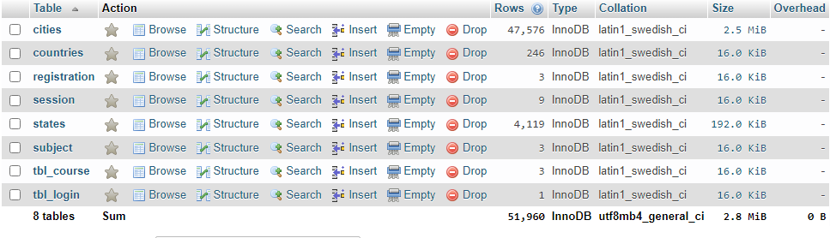

**Project Structure:**

1. **CSS** : ALL CSS FILES
2. **Icon**  : ALL ICONS OF WEB
3. **Js :**  JavaScript coding
4. **Pages :** Important pages
5. **PHP CODE** : PHP CODING
6. **Upload Image :** All images contain by System

# Chapter No :7 TESTING AND RESULT

**Security Testing of the Project:-**

Testing is vital for the success of any software. no system design is ever perfect. Testing is also carried in two phases. First phase is during the software engineering that is during the module creation. Second phase is after the completion of software. This is system testing which verifies that the whole set of programs hanged together.

**White Box Testing:-**

In this technique, the close student of the logical parts through the software is tested by cases that exercise species sets of conditions or loops. all logical parts of the software checked once. errors that can be corrected using this technique are typographical errors, logical expressions which should be executed once may be getting executed more than once and error resulting by using wrong controls and loops. When the box testing tests all the independent part within a module a logical decisions on their true and the false side are exercised , all loops and bounds within their operational bounds were exercised and internal data structure to ensure their validity were exercised once.

**Black Box Testing:-**

This method enables the software engineer to device sets of input techniques that fully exercise all functional requirements for a program. black box testing tests the input, the output and the external data. it checks whether the input data is correct and whether we are getting the desired output.

**Alpha Testing:-**

Acceptance testing is also sometimes called alpha testing. Be spoke systems are developed for a single customer. The alpha testing proceeds until the system developer and the customer agree that the provided system is an acceptable implementation of the system requirements.

**Beta Testing:-**

On the other hand, when a system is to be marked as a software product, another process called beta testing is often conducted. During beta testing, a system is delivered among a number of potential users who agree to use it. The customers then report problems to the developers. This provides the product for real use and detects errors which may not have been anticipated by the system developers.

**Unit Testing:-**

Each module is considered independently. it focuses on each unit of software as implemented in the source code. it is white box testing.

**Integration Testing:-**

Integration testing aims at constructing the program structure while at the same constructing tests to uncover errors associated with interfacing the modules. modules are integrated by using the top down approach.

**Validation Testing:-**

Validation testing was performed to ensure that all the functional and performance requirements are met. System Testing It is executing programs to check logical changes made in it with intention of finding errors. a system is tested for online response, volume of transaction, recovery from failure etc. System testing is done to ensure that the system satisfies all the user requirements.

## Chapter No 8 SCREENSHOTS AND CODING

1. **Login Page:-**

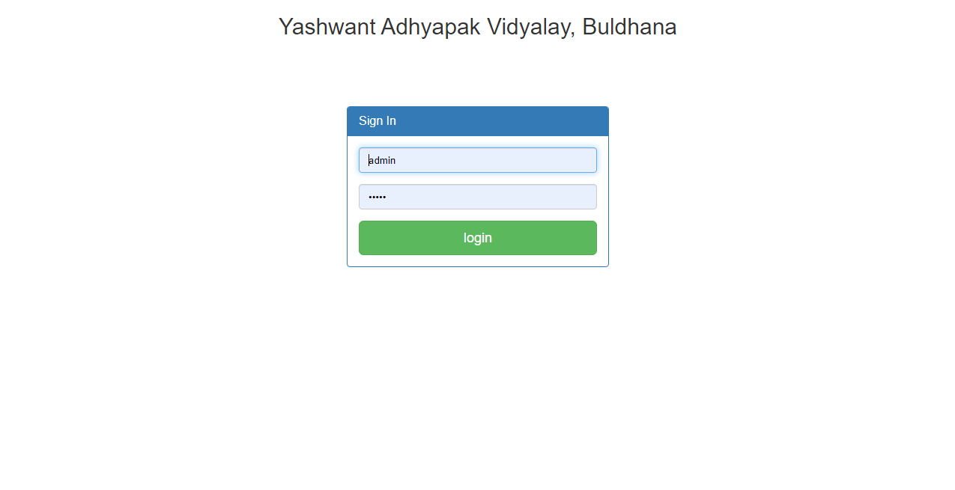

1. **Dashboard :-**

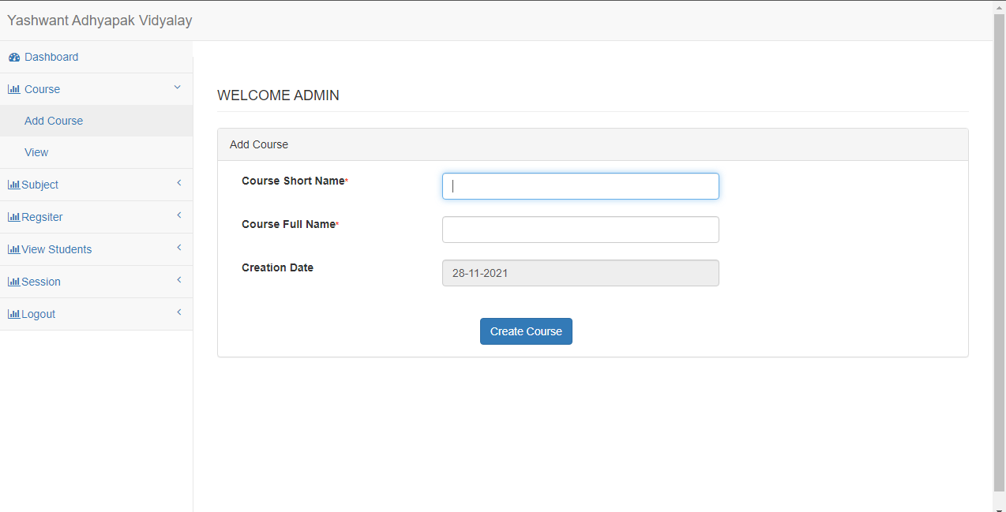

1. **Add Course::-**



1. **View Course:-**

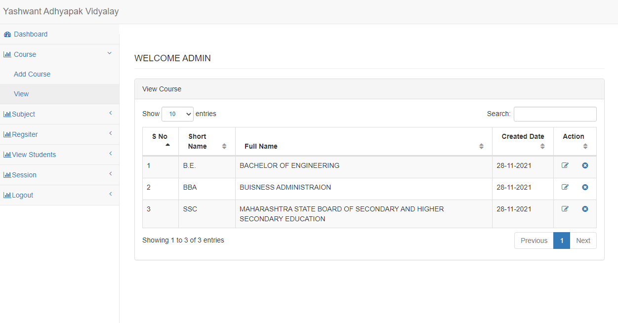

1. **Add Subject:-**

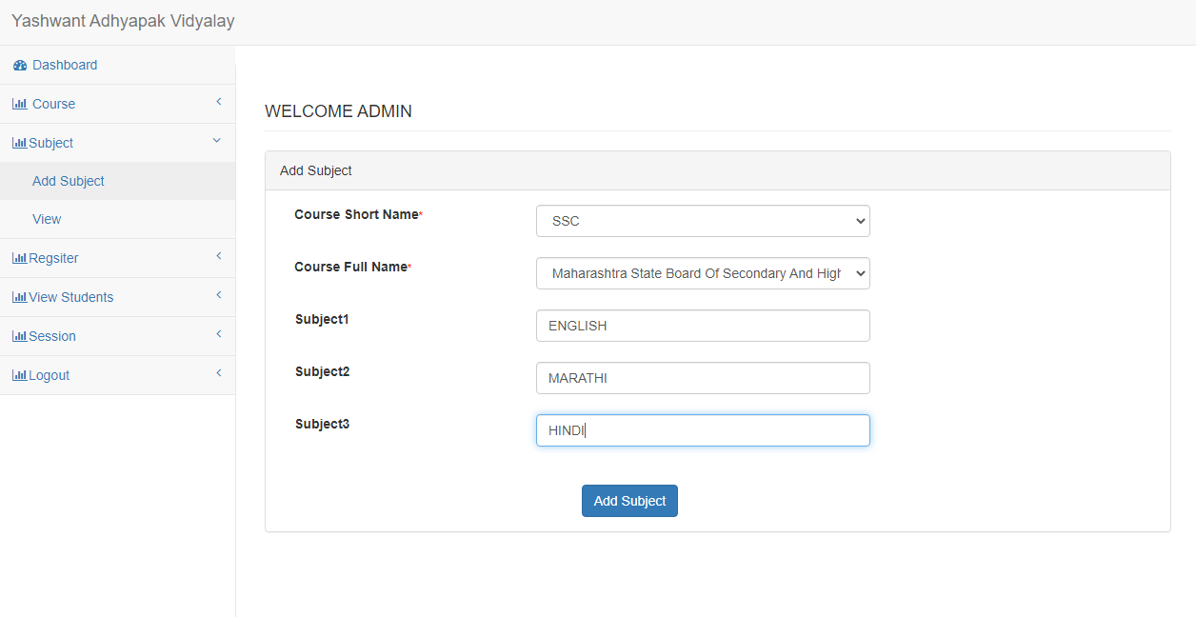

1. **View Subject:-**

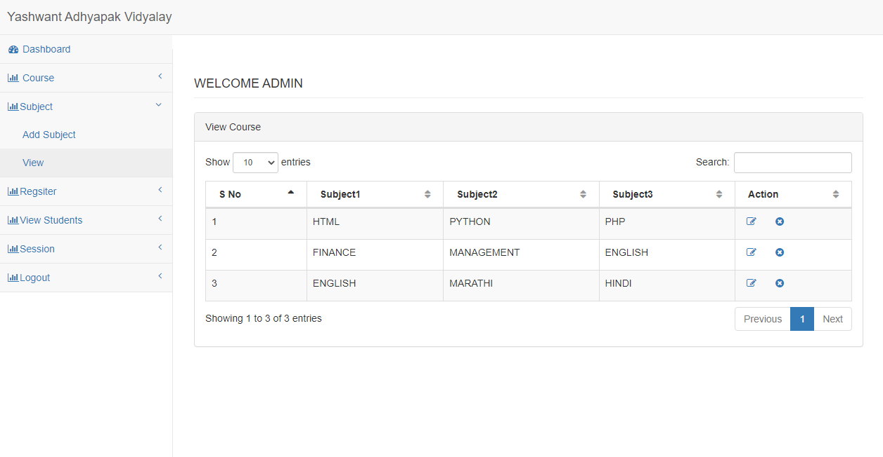

1. **Register Student:-**

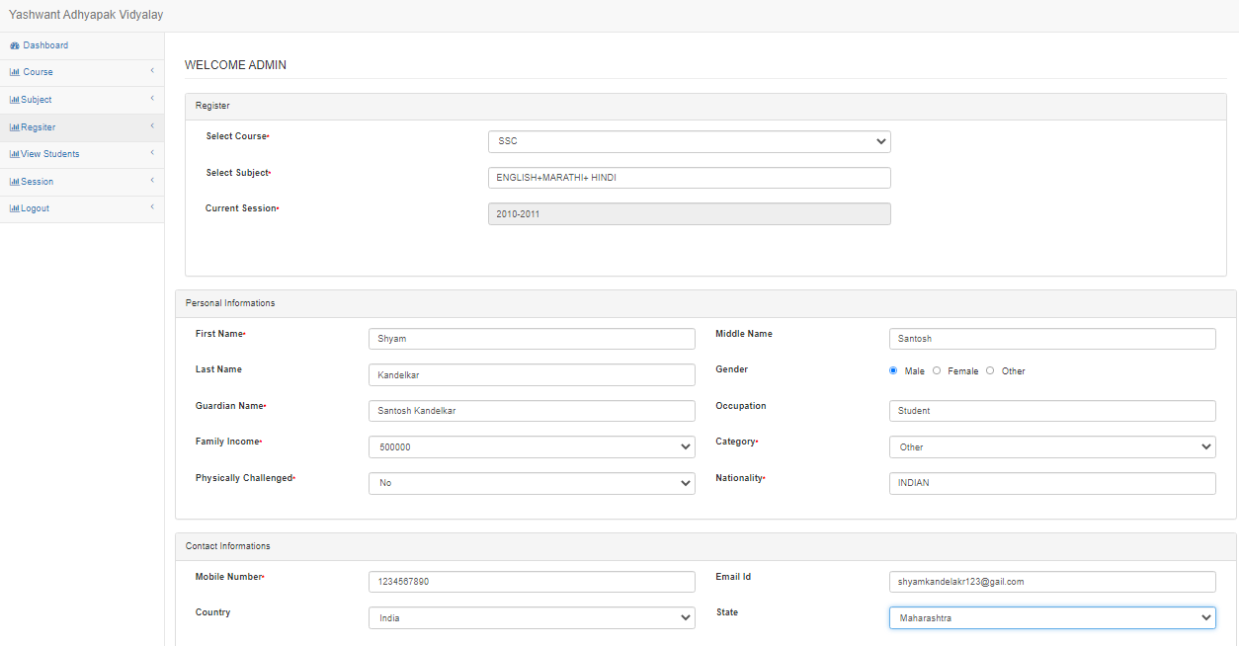

1. **View Student:-**

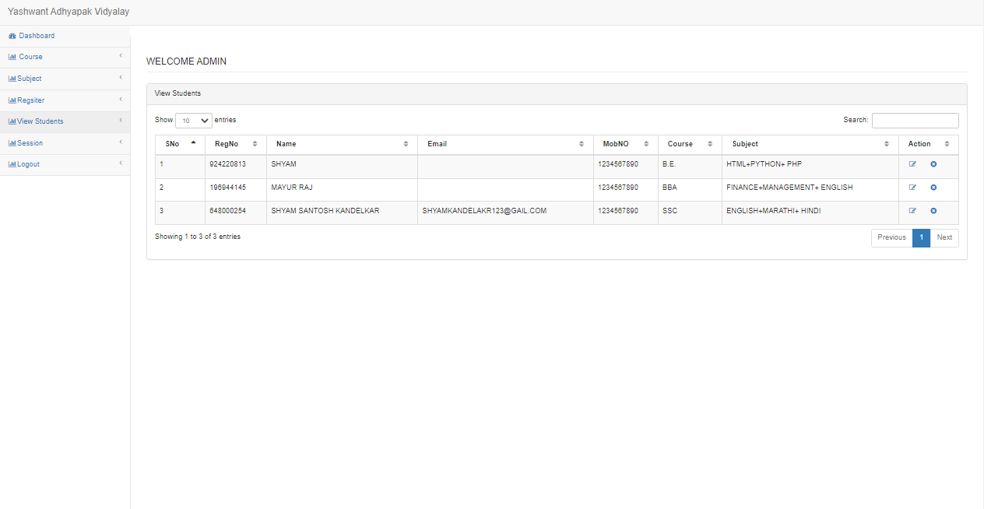

1. **Session:-**

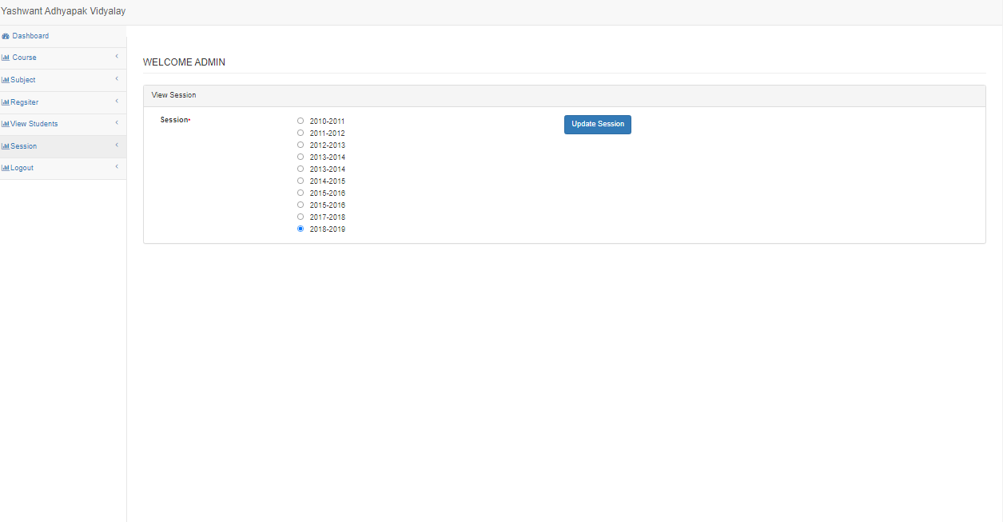

1. **Database:-**



### Coding:

**INDEX.PHP**

<?php

header('location:pages/login.php');

?>

**DBCONTROLLER.PHP**

<?php

$DB_host = "localhost";

$DB_user = "root";

$DB_pass = "";

$DB_name = "studentmanagement";

try

{

 $DB_con = new PDO("mysql:host={$DB_host};dbname={$DB_name}",$DB_user,$DB_pass);

 $DB_con->setAttribute(PDO::ATTR_ERRMODE, PDO::ERRMODE_EXCEPTION);

}

catch(PDOException $e)

{

 $e->getMessage();

}

?>

**LOGIN.PHP**

<?php

session_start();

if(isset($_POST['submit'])){

     include('../config/DbFunction.php');

     $obj=new DbFunction();

     $_SESSION['login']=$_POST['id'];

     $obj->login($_POST['id'],$_POST['password']);

}

?>

<!DOCTYPE html>

<html lang="en">

<head>

    <meta charset="utf-8">

    <meta http-equiv="X-UA-Compatible" content="IE=edge">

    <meta name="viewport" content="width=device-width, initial-scale=1">

    <meta name="description" content="">

    <meta name="author" content="">

    <title>School Management Login </title>

    <!-- Bootstrap Core CSS -->

    <link href="../bower_components/bootstrap/dist/css/bootstrap.min.css" rel="stylesheet">

    <!-- MetisMenu CSS -->

    <link href="../bower_components/metisMenu/dist/metisMenu.min.css" rel="stylesheet">

    <!-- Custom CSS -->

    <link href="../dist/css/sb-admin-2.css" rel="stylesheet">

    <!-- Custom Fonts -->

    <link href="../bower_components/font-awesome/css/font-awesome.min.css" rel="stylesheet" type="text/css">

<link rel="stylesheet" type="text/css" href="../dist/css/jquery.validate.css" />

    <!-- HTML5 Shim and Respond.js IE8 support of HTML5 elements and media queries -->

    <!-- WARNING: Respond.js doesn't work if you view the page via file:// -->

    <!--[if lt IE 9]>

        <script src="https://oss.maxcdn.com/libs/html5shiv/3.7.0/html5shiv.js"></script>

        <script src="https://oss.maxcdn.com/libs/respond.js/1.4.2/respond.min.js"></script>

    <![endif]-->

</head>

<body>

 <h2 align="center">Yashwant Adhyapak Vidyalay, Buldhana</h2>

    <div class="container">

        <br><br><br><br>

            <div class="col-md-4 col-md-offset-4">

                <div class="panel panel-primary">

                    <div class="panel-heading">

                     <h3 class="panel-title">Sign In</h3>

                    </div>

                    <div class="panel-body">

                        <form method="post">

                            <fieldset>

                                <div class="form-group">

             <input class="form-control" placeholder="Login Id"  id="id"name="id" type="text" autofocus autocomplete="off">

                                </div>

                                <div class="form-group">

                                    <input class="form-control" placeholder="Password" id="password"name="password" type="password" value="">

                                </div>

                                <!-- Change this to a button or input when using this as a form -->

                                <input type="submit" value="login" name="submit" class="btn btn-lg btn-success btn-block">

                            </fieldset>

                        </form>

                    </div>

                </div>

            </div>

        </div>

    </div>

    <!-- jQuery -->

    <script src="../bower_components/jquery/dist/jquery.min.js"></script>

    <!-- Bootstrap Core JavaScript -->

    <script src="../bower_components/bootstrap/dist/js/bootstrap.min.js"></script>

    <!-- Metis Menu Plugin JavaScript -->

    <script src="../bower_components/metisMenu/dist/metisMenu.min.js"></script>

    <!-- Custom Theme JavaScript -->

    <script src="../dist/js/sb-admin-2.js"></script>

 <script src="../dist/jquery-1.3.2.js" type="text/javascript"></script>

 <script src="../dist/jquery.validate.js" type="text/javascript"></script>

 <script type="text/javascript">

            jQuery(function(){

                jQuery("#id").validate({

                    expression: "if (VAL.match(/^[a-z]$/)) return true; else return false;",

                    message: "Should be a valid id"

                });

                jQuery("#password").validate({

                    expression: "if (VAL.match(/^[a-z]$/)) return true; else return false;",

                    message: "Should be a valid password"

                });

            });

        </script>

</body>

</html>

**REGISTER.PHP**

<?php

session_start ();

if (! (isset ( $_SESSION ['login'] ))) {

    header ( 'location:../index.php' );

}

include('../config/DbFunction.php');

    $obj=new DbFunction();

    $rs=$obj->showCourse();

    $rs1=$obj->showCountry();

    $ses=$obj->showSession();

    $res1=$ses->fetch_object();

    //$res1->session;

    if(isset($_POST['submit'])){

     $obj->register($_POST['course-short'],$_POST['c-full'],$_POST['fname'],$_POST['mname'],$_POST['lname'],

                    $_POST['gname'],$_POST['ocp'],$_POST['gender'],$_POST['income'],$_POST['category'],$_POST['ph'],$_POST['nation']

                     , $_POST['mobno'],$_POST['email'],$_POST['country'],$_POST['state'],$_POST['city'],$_POST['padd'],

                      $_POST['cadd'],$_POST['board1'],$_POST['board2'],$_POST['roll1'],$_POST['roll2'],$_POST['pyear1'],

                      $_POST['pyear2'],$_POST['sub1'],$_POST['sub2'],$_POST['marks1'],$_POST['marks2'],$_POST['fmarks1'],

                      $_POST['fmarks2'] ,$_POST['session']);

}

?>

<!DOCTYPE html>

<html lang="en">

<head>

<meta charset="utf-8">

<meta http-equiv="X-UA-Compatible" content="IE=edge">

<meta name="viewport" content="width=device-width, initial-scale=1">

<meta name="description" content="">

<meta name="author" content="">

<title>register</title>

<link href="../bower_components/bootstrap/dist/css/bootstrap.min.css"

    rel="stylesheet">

<link href="../bower_components/metisMenu/dist/metisMenu.min.css"

    rel="stylesheet">

<link href="../dist/css/sb-admin-2.css" rel="stylesheet">

<link href="../bower_components/font-awesome/css/font-awesome.min.css"

    rel="stylesheet" type="text/css">

</head>

<body>

<form method="post" >

    <div id="wrapper">

    <?php include('leftbar.php');?>

        <div id="page-wrapper">

            <div class="row">

                <div class="col-lg-12">

                    <h4 class="page-header"> <?php echo strtoupper("welcome"." ".htmlentities($_SESSION['login']));?></h4>

                </div>

                <!-- /.col-lg-12 -->

            </div>

            <!-- /.row -->

            <div class="row">

            <div class="col-lg-12">

            <div class="panel panel-default">

            <div class="panel-heading">Register</div>

            <div class="panel-body">

            <div class="row">

            <div class="col-lg-10">

            <div class="form-group">

            <div class="col-lg-4">

            <label>Select Course<span id="" style="font-size:11px;color:red">*</span>   </label>

            </div>

            <div class="col-lg-6">

<select class="form-control" name="course-short" id="cshort"  onchange="showSub(this.value)" required="required" >

<option VALUE="">SELECT</option>

                <?php while($res=$rs->fetch_object()){?>

                        <option VALUE="<?php echo htmlentities($res->cid);?>"><?php echo htmlentities($res->cshort)?></option>

                    <?php }?>   </select>

                                        </div>

                                        </div>

                                <br><br>

        <div class="form-group">

        <div class="col-lg-4">

        <label>Select Subject<span id="" style="font-size:11px;color:red">*</span></label>

        </div>

        <div class="col-lg-6">

 <input class="form-control" name="c-full"  id="c-full" >

       </select>

    </div>

     </div>

     <br><br>

            <div class="form-group">

        <div class="col-lg-4">

        <label>Current  Session<span id="" style="font-size:11px;color:red">*</span></label>

        </div>

        <div class="col-lg-6">

       <input class="form-control" name="session" value="<?php echo htmlentities($res1->session);?>" readonly>

     </div>

     <br><br>

    </div>

    <br><br>

                </div>

                    </div>

                            </div>

                        </div>

                    </div>

            <div class="row">

            <div class="col-lg-12">

            <div class="panel panel-default">

            <div class="panel-heading">Personal Informations</div>

            <div class="panel-body">

            <div class="row">

            <div class="col-lg-12">

            <div class="form-group">

            <div class="col-lg-2">

            <label>First Name<span id="" style="font-size:11px;color:red">*</span>  </label>

            </div>

            <div class="col-lg-4">

            <input class="form-control" name="fname" required="required" pattern="[A-Za-z]+$">

            </div>

             <div class="col-lg-2">

            <label>Middle Name</label>

            </div>

            <div class="col-lg-4">

            <input class="form-control" name="mname">

            </div>

            </div>

            <br><br>

        <div class="form-group">

            <div class="col-lg-2">

            <label>Last Name</label>

            </div>

            <div class="col-lg-4">

            <input class="form-control" name="lname" pattern="[A-Za-z]+$">

            </div>

             <div class="col-lg-2">

            <label>Gender</label>

            </div>

            <div class="col-lg-4">

         <input type="radio" name="gender" id="male" value="Male"> &nbsp; Male &nbsp;

         <input type="radio" name="gender" id="female" value="feale"> &nbsp; Female &nbsp;

         <input type="radio" name="gender" id="other" value="other"> &nbsp; Other &nbsp;

            </div>

            </div>

    <br><br>

             <div class="form-group">

             <div class="col-lg-2">

            <label>Guardian Name<span id="" style="font-size:11px;color:red">*</span>   </label>

            </div>

            <div class="col-lg-4">

            <input class="form-control" name="gname" required="required" pattern="[A-Za-z]+$">

            </div>

             <div class="col-lg-2">

            <label>Occupation</label>

            </div>

            <div class="col-lg-4">

            <input class="form-control" name="ocp" id="ocp">

            </div>

            </div>

            <br><br>

             <div class="form-group">

             <div class="col-lg-2">

            <label>Family Income<span id="" style="font-size:11px;color:red">*</span></label>

            </div>

            <div class="col-lg-4">

            <select class="form-control" name="income"  id="income"required="required" >

        <option VALUE="">SELECT</option>

        <option VALUE="200000">200000</option>

        <option value="500000">500000</option>

        <option value="700000">700000</option>

       </select>

            </div>

             <div class="col-lg-2">

            <label>Category<span id="" style="font-size:11px;color:red">*</span></label>

            </div>

            <div class="col-lg-4">

            <select class="form-control" name="category"  id="category" required="required" >

        <option VALUE="">SELECT</option>

        <option VALUE="general">General</option>

        <option value="obc">OBC</option>

        <option value="sc">SC</option>

        <option value="st">ST</option>

        <option value="other">Other</option>

       </select>

            </div>

            </div>

            <br><br>

             <div class="form-group">

             <div class="col-lg-2">

            <label>Physically Challenged<span id="" style="font-size:11px;color:red">*</span></label>

            </div>

            <div class="col-lg-4">

            <select class="form-control" name="ph"  id="ph"required="required" >

        <option VALUE="">SELECT</option>

        <option VALUE="yes">Yes</option>

        <option value="no">No</option>

       </select>

            </div>

             <div class="col-lg-2">

            <label>Nationality<span id="" style="font-size:11px;color:red">*</span></label>

            </div>

            <div class="col-lg-4">

            <input class="form-control" name="nation" id="nation">

            </div>

            </div>

            <br><br>

            </div>

            <br><br>

        </div>

        </div>

        </div>

        <div class="row">

            <div class="col-lg-12">

            <div class="panel panel-default">

            <div class="panel-heading">Contact Informations</div>

            <div class="panel-body">

            <div class="row">

            <div class="col-lg-12">

            <div class="form-group">

            <div class="col-lg-2">

            <label>Mobile Number<span id="" style="font-size:11px;color:red">*</span>   </label>

            </div>

            <div class="col-lg-4">

            <input class="form-control" type="number" name="mobno" required="required" maxlength="10">

            </div>

             <div class="col-lg-2">

            <label>Email Id</label>

            </div>

            <div class="col-lg-4">

            <input class="form-control"  type="email" name="email">

            </div>

            </div>

            <br><br>

        <div class="form-group">

            <div class="col-lg-2">

            <label>Country</label>

            </div>

            <div class="col-lg-4">

            <select class="form-control" name="country" id="country" onchange="showState(this.value)" required="required" >

<option VALUE="">Select Country</option>

                <?php while($res=$rs1->fetch_object()){?>

   <option VALUE="<?php echo htmlentities($res->id);?>"><?php echo htmlentities($res->name)?></option>

                    <?php }?>   </select>

            </div>

             <div class="col-lg-2">

            <label>State</label>

            </div>

            <div class="col-lg-4">

 <select name="state" id="state"  class="form-control" onchange="showDist(this.value)" required="required">

        <option value="">Select State</option>

        </select>

            </div>

            </div>

    <br><br><br><br>

             <div class="form-group">

             <div class="col-lg-2">

            <label>City<span id="" style="font-size:11px;color:red">*</span>    </label>

            </div>

            <div class="col-lg-4">

           <select name="city" id="dist"  class="form-control" onchange="" required="required">

        <option value="">Select City</option>

        </select>

            </div>

             <div class="col-lg-2">

            <label>Permanent Address<span id="" style="font-size:11px;color:red">*</span></label>

            </div>

            <div class="col-lg-4">

            <textarea class="form-control" rows="3" name="padd" id="padd"></textarea>

            </div>

            </div>

            <br><br><br><br>

            <br><br>

             <div class="form-group">

             <div class="col-lg-2">

            <label>Correspondence Address<span id="" style="font-size:11px;color:red">*</span>

            </div>

            <div class="col-lg-4">

      <textarea class="form-control" rows="3" name="cadd"  id="cadd"></textarea>

            </div>

             <div class="col-lg-2">

            </div>

            <div class="col-lg-4">

            </div>

            </div>

            <br><br>

            </div>

            <br><br>

        </div>

        </div>

        </div>

        <div class="row">

            <div class="col-lg-12">

            <div class="panel panel-default">

            <div class="panel-heading">Academic Informations</div>

            <div class="panel-body">

            <div class="row">

            <div class="col-lg-12">

            <div class="form-group">

            <div class="panel panel-default">

            <!-- /.panel-heading -->

                        <div class="panel-body">

                            <div class="table-responsive">

                                <table class="table">

                                    <thead>

                                        <tr>

                                         <div class="col-lg-6">

            <th>&nbsp;&nbsp;&nbsp;&nbsp;Board<span id="" style="font-size:11px;color:red">*</span>  </label></th>

            </div>

            <div class="col-lg-6">

            <th>&nbsp;&nbsp;&nbsp;&nbsp;Roll No</th>

            </div>

              <div class="col-lg-6">

             <th>&nbsp;&nbsp;&nbsp;&nbsp;Year Of Passing<span id="" style="font-size:11px;color:red">*</span></th>

            </div>

            </tr>

                                    </thead>

                                    <tbody>

                                        <tr>

                  <td><div class="col-lg-6">

                  <input class="form-control" type="text" name="board1">

                  </div></td>

                  <td><div class="col-lg-6">

            <input class="form-control" type="text" name="roll1" >

            </div></td>

            <td><div class="col-lg-6">

            <input class="form-control"  type="text" name="pyear1" >

            </div></td>

                  </tr>

              <tr>

                  <td><div class="col-lg-6">

                  <input class="form-control" type="text" name="board2" >

                  </div></td>

                  <td><div class="col-lg-6">

            <input class="form-control" type="text" name="roll2" >

            </div></td>

            <td><div class="col-lg-6">

            <input class="form-control"  type="text" name="pyear2" >

            </div></td>

                  </tr>

                                    </tbody>

                                </table>

                            </div>

                            <!-- /.table-responsive -->

                        <!-- /.panel-body -->

                    </div>

                    <!-- /.panel -->

                </div>

            </div>

            <br><br>

          </div>

            <br><br>

            <br><br>

            <div class="col-lg-12">

            <div class="form-group">

            <div class="panel panel-default">

            <!-- /.panel-heading -->

                        <div class="panel-body">

                            <div class="table-responsive">

                                <table class="table">

                                    <thead>

                                        <tr>

                                         <div class="col-lg-6">

            <th>S.No</th>

            </div>

            <div class="col-lg-6">

            <th>&nbsp;&nbsp;&nbsp;&nbsp;Subject</th>

            </div>

              <div class="col-lg-6">

             <th>&nbsp;&nbsp;&nbsp;&nbsp;Marks Obtained</th>

            </div>

             <div class="col-lg-6">

               <th>&nbsp;&nbsp;&nbsp;&nbsp;Full Marks</th>

            </div>

                                        </tr>

                                    </thead>

                                    <tbody>

                                        <tr>

                  <td>1</td>

                  <td><div class="col-lg-6">

            <input class="form-control"  type="text" name="sub1">

            </div></td>

                  <td><div class="col-lg-6">

            <input class="form-control"  type="text" name="marks1">

            </div></td>

                              <td><div class="col-lg-6">

            <input class="form-control"  type="text" name="fmarks1">

            </div></td>

                  </tr>

             <tr>

                  <td>2</td>

                  <td><div class="col-lg-6">

            <input class="form-control"  type="text" name="sub2">

            </div></td>

                  <td><div class="col-lg-6">

            <input class="form-control"  type="text" name="marks2">

            </div></td>

                              <td><div class="col-lg-6">

            <input class="form-control"  type="text" name="fmarks2">

            </div></td>

                  </tr>

                                    </tbody>

                                </table>

                            </div>

                            <!-- /.table-responsive -->

                        <!-- /.panel-body -->

                    </div>

                    <!-- /.panel -->

                </div>

            </div>

          </div>

            <br>

    <div class="form-group">

    <div class="col-lg-4">

    </div>

    <div class="col-lg-6"><br><br>

    <input type="submit" class="btn btn-primary" name="submit" value="Register"></button>

    </div>

    </div>

    </div>

    </div><!--row!-->

    </div>

            </div>

        </div>

    </div>

    </form>

    <!-- jQuery -->

    <script src="../bower_components/jquery/dist/jquery.min.js"

        type="text/javascript"></script>

    <!-- Bootstrap Core JavaScript -->

    <script src="../bower_components/bootstrap/dist/js/bootstrap.min.js"

        type="text/javascript"></script>

    <!-- Metis Menu Plugin JavaScript -->

    <script src="../bower_components/metisMenu/dist/metisMenu.min.js"

        type="text/javascript"></script>

    <!-- Custom Theme JavaScript -->

    <script src="../dist/js/sb-admin-2.js" type="text/javascript"></script>

    <script>

function showState(val) {

    $.ajax({

    type: "POST",

    url: "subject.php",

    data:'id='+val,

    success: function(data){

      // alert(data);

        $("#state").html(data);

    }

    });

}

function showDist(val) {

    $.ajax({

    type: "POST",

    url: "subject.php",

    data:'did='+val,

    success: function(data){

      // alert(data);

        $("#dist").html(data);

    }

    });

}

function showSub(val) {

    //alert(val);

    $.ajax({

    type: "POST",

    url: "subject.php",

    data:'cid='+val,

    success: function(data){

      // alert(data);

        $("#c-full").val(data);

    }

    });

}

</script>

</body>

</html>

**LOGOUT.PHP**

<?php

session_start();

unset($_SESSION['login']);

session_destroy();

header('Location:../index.php');

?>

**DASHBOARD.PHP**

<?php session_start();

if (!(isset($_SESSION['login']))) {

    header('location:../index.php');

}

?>

<!DOCTYPE html>

<html lang="en">

<head>

    <meta charset="utf-8">

    <meta http-equiv="X-UA-Compatible" content="IE=edge">

    <meta name="viewport" content="width=device-width, initial-scale=1">

    <meta name="description" content="">

    <meta name="author" content="">

    <title></title>

    <!-- Bootstrap Core CSS -->

    <link href="../bower_components/bootstrap/dist/css/bootstrap.min.css" rel="stylesheet">

    <!-- MetisMenu CSS -->

    <link href="../bower_components/metisMenu/dist/metisMenu.min.css" rel="stylesheet">

    <!-- Custom CSS -->

    <link href="../dist/css/sb-admin-2.css" rel="stylesheet">

    <!-- Custom Fonts -->

    <link href="../bower_components/font-awesome/css/font-awesome.min.css" rel="stylesheet" type="text/css">

    <!-- HTML5 Shim and Respond.js IE8 support of HTML5 elements and media queries -->

    <!-- WARNING: Respond.js doesn't work if you view the page via file:// -->

    <!--[if lt IE 9]>

        <script src="https://oss.maxcdn.com/libs/html5shiv/3.7.0/html5shiv.js"></script>

        <script src="https://oss.maxcdn.com/libs/respond.js/1.4.2/respond.min.js"></script>

    <![endif]-->

</head>

<body>

    <div id="wrapper">

        <!-- Navigation -->

        <nav class="navbar navbar-default navbar-static-top" role="navigation" style="margin-bottom: 0">

            <div class="navbar-header">

                <button type="button" class="navbar-toggle" data-toggle="collapse" data-target=".navbar-collapse">

                    <span class="sr-only">Toggle navigation</span>

                    <span class="icon-bar"></span>

                    <span class="icon-bar"></span>

                    <span class="icon-bar"></span>

                </button>

                <a class="navbar-brand" href="dashboard.html">Yashwant Adhyapak Vidyalay Dashboard</a>

            </div>

            <!-- /.navbar-header -->

            <ul class="nav navbar-top-links navbar-right">

                <li class="dropdown">

                    <a class="dropdown-toggle" data-toggle="dropdown" href="#">

                        <i class="fa fa-envelope fa-fw"></i>  <i class="fa fa-caret-down"></i>

                    </a>

                    <ul class="dropdown-menu dropdown-messages">

                        <li>

                            <a href="#">

                                <div>

                                    <strong>John Smith</strong>

                                    <span class="pull-right text-muted">

                                        <em>Yesterday</em>

                                    </span>

                                </div>

                                <div>Lorem ipsum dolor sit amet, consectetur adipiscing elit. Pellentesque eleifend...</div>

                            </a>

                        </li>

                        <li class="divider"></li>

                        <li>

                            <a href="#">

                                <div>

                                    <strong>John Smith</strong>

                                    <span class="pull-right text-muted">

                                        <em>Yesterday</em>

                                    </span>

                                </div>

                                <div>Lorem ipsum dolor sit amet, consectetur adipiscing elit. Pellentesque eleifend...</div>

                            </a>

                        </li>

                        <li class="divider"></li>

                        <li>

                            <a href="#">

                                <div>

                                    <strong>John Smith</strong>

                                    <span class="pull-right text-muted">

                                        <em>Yesterday</em>

                                    </span>

                                </div>

                                <div>Lorem ipsum dolor sit amet, consectetur adipiscing elit. Pellentesque eleifend...</div>

                            </a>

                        </li>

                        <li class="divider"></li>

                        <li>

                            <a class="text-center" href="#">

                                <strong>Read All Messages</strong>

                                <i class="fa fa-angle-right"></i>

                            </a>

                        </li>

                    </ul>

                    <!-- /.dropdown-messages -->

                </li>

                <!-- /.dropdown -->

                <li class="dropdown">

                    <a class="dropdown-toggle" data-toggle="dropdown" href="#">

                        <i class="fa fa-tasks fa-fw"></i>  <i class="fa fa-caret-down"></i>

                    </a>

                    <ul class="dropdown-menu dropdown-tasks">

                        <li>

                            <a href="#">

                                <div>

                                    <p>

                                        <strong>Task 1</strong>

                                        <span class="pull-right text-muted">40% Complete</span>

                                    </p>

                                    <div class="progress progress-striped active">

                                        <div class="progress-bar progress-bar-success" role="progressbar" aria-valuenow="40" aria-valuemin="0" aria-valuemax="100" style="width: 40%">

                                            <span class="sr-only">40% Complete (success)</span>

                                        </div>

                                    </div>

                                </div>

                            </a>

                        </li>

                        <li class="divider"></li>

                        <li>

                            <a href="#">

                                <div>

                                    <p>

                                        <strong>Task 2</strong>

                                        <span class="pull-right text-muted">20% Complete</span>

                                    </p>

                                    <div class="progress progress-striped active">

                                        <div class="progress-bar progress-bar-info" role="progressbar" aria-valuenow="20" aria-valuemin="0" aria-valuemax="100" style="width: 20%">

                                            <span class="sr-only">20% Complete</span>

                                        </div>

                                    </div>

                                </div>

                            </a>

                        </li>

                        <li class="divider"></li>

                        <li>

                            <a href="#">

                                <div>

                                    <p>

                                        <strong>Task 3</strong>

                                        <span class="pull-right text-muted">60% Complete</span>

                                    </p>

                                    <div class="progress progress-striped active">

                                        <div class="progress-bar progress-bar-warning" role="progressbar" aria-valuenow="60" aria-valuemin="0" aria-valuemax="100" style="width: 60%">

                                            <span class="sr-only">60% Complete (warning)</span>

                                        </div>

                                    </div>

                                </div>

                            </a>

                        </li>

                        <li class="divider"></li>

                        <li>

                            <a href="#">

                                <div>

                                    <p>

                                        <strong>Task 4</strong>

                                        <span class="pull-right text-muted">80% Complete</span>

                                    </p>

                                    <div class="progress progress-striped active">

                                        <div class="progress-bar progress-bar-danger" role="progressbar" aria-valuenow="80" aria-valuemin="0" aria-valuemax="100" style="width: 80%">

                                            <span class="sr-only">80% Complete (danger)</span>

                                        </div>

                                    </div>

                                </div>

                            </a>

                        </li>

                        <li class="divider"></li>

                        <li>

                            <a class="text-center" href="#">

                                <strong>See All Tasks</strong>

                                <i class="fa fa-angle-right"></i>

                            </a>

                        </li>

                    </ul>

                    <!-- /.dropdown-tasks -->

                </li>

                <!-- /.dropdown -->

                <li class="dropdown">

                    <a class="dropdown-toggle" data-toggle="dropdown" href="#">

                        <i class="fa fa-bell fa-fw"></i>  <i class="fa fa-caret-down"></i>

                    </a>

                    <ul class="dropdown-menu dropdown-alerts">

                        <li>

                            <a href="#">

                                <div>

                                    <i class="fa fa-comment fa-fw"></i> New Comment

                                    <span class="pull-right text-muted small">4 minutes ago</span>

                                </div>

                            </a>

                        </li>

                        <li class="divider"></li>

                        <li>

                            <a href="#">

                                <div>

                                    <i class="fa fa-twitter fa-fw"></i> 3 New Followers

                                    <span class="pull-right text-muted small">12 minutes ago</span>

                                </div>

                            </a>

                        </li>

                        <li class="divider"></li>

                        <li>

                            <a href="#">

                                <div>

                                    <i class="fa fa-envelope fa-fw"></i> Message Sent

                                    <span class="pull-right text-muted small">4 minutes ago</span>

                                </div>

                            </a>

                        </li>

                        <li class="divider"></li>

                        <li>

                            <a href="#">

                                <div>

                                    <i class="fa fa-tasks fa-fw"></i> New Task

                                    <span class="pull-right text-muted small">4 minutes ago</span>

                                </div>

                            </a>

                        </li>

                        <li class="divider"></li>

                        <li>

                            <a href="#">

                                <div>

                                    <i class="fa fa-upload fa-fw"></i> Server Rebooted

                                    <span class="pull-right text-muted small">4 minutes ago</span>

                                </div>

                            </a>

                        </li>

                        <li class="divider"></li>

                        <li>

                            <a class="text-center" href="#">

                                <strong>See All Alerts</strong>

                                <i class="fa fa-angle-right"></i>

                            </a>

                        </li>

                    </ul>

                    <!-- /.dropdown-alerts -->

                </li>

                <!-- /.dropdown -->

                <li class="dropdown">

                    <a class="dropdown-toggle" data-toggle="dropdown" href="#">

                        <i class="fa fa-user fa-fw"></i>  <i class="fa fa-caret-down"></i>

                    </a>

                    <ul class="dropdown-menu dropdown-user">

                        <li><a href="#"><i class="fa fa-user fa-fw"></i> User Profile</a>

                        </li>

                        <li><a href="#"><i class="fa fa-gear fa-fw"></i> Settings</a>

                        </li>

                        <li class="divider"></li>

                        <li><a href="login.html"><i class="fa fa-sign-out fa-fw"></i> Logout</a>

                        </li>

                    </ul>

                    <!-- /.dropdown-user -->

                </li>

                <!-- /.dropdown -->

            </ul>

            <!-- /.navbar-top-links -->

            <div class="navbar-default sidebar" role="navigation">

                <div class="sidebar-nav navbar-collapse">

                    <ul class="nav" id="side-menu">

                        <li>

                   <a href="dashboard.php"><i class="fa fa-dashboard fa-fw"></i> Dashboard</a>

                        </li>

                        <li>

                            <a href="#"><i class="fa fa-bar-chart-o fa-fw"></i> Course<span class="fa arrow"></span></a>

                            <ul class="nav nav-second-level">

                                <li>

                                    <a href="add-course.php">Add Course</a>

                                </li>

                                <li>

                                    <a href="?">View</a>

                                </li>

                            </ul>

                            <!-- /.nav-second-level -->

                        </li>

                        <li>

                            <a href="tables.html"><i class="fa fa-table fa-fw"></i> Tables</a>

                        </li>

                        <li>

                            <a href="forms.html"><i class="fa fa-edit fa-fw"></i> Forms</a>

                        </li>

                        <li>

                            <a href="#"><i class="fa fa-wrench fa-fw"></i> UI Elements<span class="fa arrow"></span></a>

                            <ul class="nav nav-second-level">

                                <li>

                                    <a href="panels-wells.html">Panels and Wells</a>

                                </li>

                                <li>

                                    <a href="buttons.html">Buttons</a>

                                </li>

                                <li>

                                    <a href="notifications.html">Notifications</a>

                                </li>

                                <li>

                                    <a href="typography.html">Typography</a>

                                </li>

                                <li>

                                    <a href="icons.html"> Icons</a>

                                </li>

                                <li>

                                    <a href="grid.html">Grid</a>

                                </li>

                            </ul>

                            <!-- /.nav-second-level -->

                        </li>

                        <li>

                            <a href="#"><i class="fa fa-sitemap fa-fw"></i> Multi-Level Dropdown<span class="fa arrow"></span></a>

                            <ul class="nav nav-second-level">

                                <li>

                                    <a href="#">Second Level Item</a>

                                </li>

                                <li>

                                    <a href="#">Second Level Item</a>

                                </li>

                                <li>

                                    <a href="#">Third Level <span class="fa arrow"></span></a>

                                    <ul class="nav nav-third-level">

                                        <li>

                                            <a href="#">Third Level Item</a>

                                        </li>

                                        <li>

                                            <a href="#">Third Level Item</a>

                                        </li>

                                        <li>

                                            <a href="#">Third Level Item</a>

                                        </li>

                                        <li>

                                            <a href="#">Third Level Item</a>

                                        </li>

                                    </ul>

                                    <!-- /.nav-third-level -->

                                </li>

                            </ul>

                            <!-- /.nav-second-level -->

                        </li>

                        <li>

                            <a href="#"><i class="fa fa-files-o fa-fw"></i> Sample Pages<span class="fa arrow"></span></a>

                            <ul class="nav nav-second-level">

                                <li>

                                    <a href="blank.html">Blank Page</a>

                                </li>

                                <li>

                                    <a href="login.html">Login Page</a>

                                </li>

                            </ul>

                            <!-- /.nav-second-level -->

                        </li>

                    </ul>

                </div>

                <!-- /.sidebar-collapse -->

            </div>

            <!-- /.navbar-static-side -->

        </nav>

        <div id="page-wrapper">

            <div class="row">

                <div class="col-lg-12">

                    <h4 class="page-header"> <?php echo strtoupper("welcome"." ".htmlentities($_SESSION['login']));?></h4>

                </div>

                <!-- /.col-lg-12 -->

            </div>

            <!-- /.row -->

            <div class="row">

                <div class="col-lg-12">

                    <div class="panel panel-default">

                        <div class="panel-heading">

                            Basic Form Elements

                        </div>

                        <div class="panel-body">

                            <div class="row">

                                <div class="col-lg-6">

                                    <form role="form">

                                        <div class="form-group">

                                            <label>Text Input</label>

                                            <input class="form-control">

                                            <p class="help-block">Example block-level help text here.</p>

                                        </div>

                                        <div class="form-group">

                                            <label>Text Input with Placeholder</label>

                                            <input class="form-control" placeholder="Enter text">

                                        </div>

                                        <div class="form-group">

                                            <label>Static Control</label>

                                            <p class="form-control-static">email@example.com</p>

                                        </div>

                                        <div class="form-group">

                                            <label>File input</label>

                                            <input type="file">

                                        </div>

                                        <div class="form-group">

                                            <label>Text area</label>

                                            <textarea class="form-control" rows="3"></textarea>

                                        </div>

                                        <div class="form-group">

                                            <label>Checkboxes</label>

                                            <div class="checkbox">

                                                <label>

                                                    <input type="checkbox" value="">Checkbox 1

                                                </label>

                                            </div>

                                            <div class="checkbox">

                                                <label>

                                                    <input type="checkbox" value="">Checkbox 2

                                                </label>

                                            </div>

                                            <div class="checkbox">

                                                <label>

                                                    <input type="checkbox" value="">Checkbox 3

                                                </label>

                                            </div>

                                        </div>

                                        <div class="form-group">

                                            <label>Inline Checkboxes</label>

                                            <label class="checkbox-inline">

                                                <input type="checkbox">1

                                            </label>

                                            <label class="checkbox-inline">

                                                <input type="checkbox">2

                                            </label>

                                            <label class="checkbox-inline">

                                                <input type="checkbox">3

                                            </label>

                                        </div>

                                        <div class="form-group">

                                            <label>Radio Buttons</label>

                                            <div class="radio">

                                                <label>

                                                    <input type="radio" name="optionsRadios" id="optionsRadios1" value="option1" checked>Radio 1

                                                </label>

                                            </div>

                                            <div class="radio">

                                                <label>

                                                    <input type="radio" name="optionsRadios" id="optionsRadios2" value="option2">Radio 2

                                                </label>

                                            </div>

                                            <div class="radio">

                                                <label>

                                                    <input type="radio" name="optionsRadios" id="optionsRadios3" value="option3">Radio 3

                                                </label>

                                            </div>

                                        </div>

                                        <div class="form-group">

                                            <label>Inline Radio Buttons</label>

                                            <label class="radio-inline">

                                                <input type="radio" name="optionsRadiosInline" id="optionsRadiosInline1" value="option1" checked>1

                                            </label>

                                            <label class="radio-inline">

                                                <input type="radio" name="optionsRadiosInline" id="optionsRadiosInline2" value="option2">2

                                            </label>

                                            <label class="radio-inline">

                                                <input type="radio" name="optionsRadiosInline" id="optionsRadiosInline3" value="option3">3

                                            </label>

                                        </div>

                                        <div class="form-group">

                                            <label>Selects</label>

                                            <select class="form-control">

                                                <option>1</option>

                                                <option>2</option>

                                                <option>3</option>

                                                <option>4</option>

                                                <option>5</option>

                                            </select>

                                        </div>

                                        <div class="form-group">

                                            <label>Multiple Selects</label>

                                            <select multiple class="form-control">

                                                <option>1</option>

                                                <option>2</option>

                                                <option>3</option>

                                                <option>4</option>

                                                <option>5</option>

                                            </select>

                                        </div>

                                        <button type="submit" class="btn btn-default">Submit Button</button>

                                        <button type="reset" class="btn btn-default">Reset Button</button>

                                    </form>

                                </div>

                                <!-- /.col-lg-6 (nested) -->

                                <div class="col-lg-6">

                                    <h1>Disabled Form States</h1>

                                    <form role="form">

                                        <fieldset disabled>

                                            <div class="form-group">

                                                <label for="disabledSelect">Disabled input</label>

                                                <input class="form-control" id="disabledInput" type="text" placeholder="Disabled input" disabled>

                                            </div>

                                            <div class="form-group">

                                                <label for="disabledSelect">Disabled select menu</label>

                                                <select id="disabledSelect" class="form-control">

                                                    <option>Disabled select</option>

                                                </select>

                                            </div>

                                            <div class="checkbox">

                                                <label>

                                                    <input type="checkbox">Disabled Checkbox

                                                </label>

                                            </div>

                                            <button type="submit" class="btn btn-primary">Disabled Button</button>

                                        </fieldset>

                                    </form>

                                    <h1>Form Validation States</h1>

                                    <form role="form">

                                        <div class="form-group has-success">

                                            <label class="control-label" for="inputSuccess">Input with success</label>

                                            <input type="text" class="form-control" id="inputSuccess">

                                        </div>

                                        <div class="form-group has-warning">

                                            <label class="control-label" for="inputWarning">Input with warning</label>

                                            <input type="text" class="form-control" id="inputWarning">

                                        </div>

                                        <div class="form-group has-error">

                                            <label class="control-label" for="inputError">Input with error</label>

                                            <input type="text" class="form-control" id="inputError">

                                        </div>

                                    </form>

                                    <h1>Input Groups</h1>

                                    <form role="form">

                                        <div class="form-group input-group">

                                            <span class="input-group-addon">@</span>

                                            <input type="text" class="form-control" placeholder="Username">

                                        </div>

                                        <div class="form-group input-group">

                                            <input type="text" class="form-control">

                                            <span class="input-group-addon">.00</span>

                                        </div>

                                        <div class="form-group input-group">

                                            <span class="input-group-addon"><i class="fa fa-eur"></i>

                                            </span>

                                            <input type="text" class="form-control" placeholder="Font Awesome Icon">

                                        </div>

                                        <div class="form-group input-group">

                                            <span class="input-group-addon">$</span>

                                            <input type="text" class="form-control">

                                            <span class="input-group-addon">.00</span>

                                        </div>

                                        <div class="form-group input-group">

                                            <input type="text" class="form-control">

                                            <span class="input-group-btn">

                                                <button class="btn btn-default" type="button"><i class="fa fa-search"></i>

                                                </button>

                                            </span>

                                        </div>

                                    </form>

                                </div>

                                <!-- /.col-lg-6 (nested) -->

                            </div>

                            <!-- /.row (nested) -->

                        </div>

                        <!-- /.panel-body -->

                    </div>

                    <!-- /.panel -->

                </div>

                <!-- /.col-lg-12 -->

            </div>

            <!-- /.row -->

        </div>

        <!-- /#page-wrapper -->

    </div>

    <!-- /#wrapper -->

    <!-- jQuery -->

    <script src="../bower_components/jquery/dist/jquery.min.js"></script>

    <!-- Bootstrap Core JavaScript -->

    <script src="../bower_components/bootstrap/dist/js/bootstrap.min.js"></script>

    <!-- Metis Menu Plugin JavaScript -->

    <script src="../bower_components/metisMenu/dist/metisMenu.min.js"></script>

    <!-- Custom Theme JavaScript -->

    <script src="../dist/js/sb-admin-2.js"></script>

</body>

</html>

**VIEW.PHP**

<?php

session_start ();

if (! (isset ( $_SESSION ['login'] ))) {

    header ( 'location:../index.php' );

}

    include('../config/DbFunction.php');

    $obj=new DbFunction();

    $rs=$obj->showstudents();

    if(isset($_GET['del']))

    {

          $obj->del_std(intval($_GET['del']));

    }

?>

<!DOCTYPE html>

<html lang="en">

<head>

    <meta charset="utf-8">

    <meta http-equiv="X-UA-Compatible" content="IE=edge">

    <meta name="viewport" content="width=device-width, initial-scale=1">

    <meta name="description" content="">

    <meta name="author" content="">

    <title>View Students</title>

    <link href="../bower_components/bootstrap/dist/css/bootstrap.min.css" rel="stylesheet">

    <link href="../bower_components/metisMenu/dist/metisMenu.min.css" rel="stylesheet">

    <link href="../bower_components/datatables-plugins/integration/bootstrap/3/dataTables.bootstrap.css" rel="stylesheet">

    <link href="../bower_components/datatables-responsive/css/dataTables.responsive.css" rel="stylesheet">

    <link href="../dist/css/sb-admin-2.css" rel="stylesheet">

    <link href="../bower_components/font-awesome/css/font-awesome.min.css" rel="stylesheet" type="text/css">

</head>

<body>

    <div id="wrapper">

        <!-- Navigation -->

     <?php include('leftbar.php')?>;

         <nav>

        <div id="page-wrapper">

            <div class="row">

                <div class="col-lg-12">

                   <h4 class="page-header"> <?php echo strtoupper("welcome"." ".htmlentities($_SESSION['login']));?></h4>

                </div>

                <!-- /.col-lg-12 -->

            </div>

            <!-- /.row -->

            <div class="row">

                <div class="col-lg-12">

                    <div class="panel panel-default">

                        <div class="panel-heading">

                            View Students

                        </div>

                        <!-- /.panel-heading -->

                        <div class="panel-body">

                            <div class="dataTable_wrapper">

                                <table class="table table-striped table-bordered table-hover" id="dataTables-example">

                                    <thead>

                                        <tr>

                                            <th>SNo</th>

                                            <th>RegNo</th>

                                            <th>Name</th>

                                            <th>Email</th>

                                            <th>MobNO</th>

                                            <th>Course</th>

                                            <th>Subject</th>

                                            <th>Action</th>

                                        </tr>

                                    </thead>

                                    <tbody>

                                    <?php

                                         $sn=1;

                                     while($res=$rs->fetch_object()){

                                      $c=$res->course;

                                      $cname=$obj->showCourse1($c);

                                      $res1=$cname->fetch_object();

                                     ?>

                                        <tr class="odd gradeX">

                              <td><?php echo $sn?></td>

                              <td><?php echo htmlentities( strtoupper($res->regno));?></td>

             <td><?php echo htmlentities(strtoupper($res->fname." ".$res->mname." ".$res->lname));?></td>

       <td><?php echo htmlentities(strtoupper($res->emailid));?></td>

      <td><?php echo htmlentities($res->mobno);?></td>

      <td><?php echo htmlentities(strtoupper($res1->cshort));?></td>

      <td><?php echo htmlentities(strtoupper($res->subject));?></td>

      <td>&nbsp;&nbsp;<a href="edit-std.php?id=<?php echo htmlentities($res->id);?>">

      <p class="fa fa-edit"></p></a> &nbsp;&nbsp;&nbsp;&nbsp;&nbsp;

      <a href="view.php?del=<?php echo htmlentities($res->id); ?>">

      <p class="fa fa-times-circle"></p>

      </td>

                                        </tr>

                                    <?php $sn++;}?>

                                    </tbody>

                                </table>

                            </div>

                            <!-- /.table-responsive -->

                        </div>

                        <!-- /.panel-body -->

                    </div>

                    <!-- /.panel -->

                </div>

                <!-- /.col-lg-12 -->

            </div>

            <!-- /.row -->

        </div>

        <!-- /#page-wrapper -->

    </div>

    <!-- /#wrapper -->

    <!-- jQuery -->

    <script src="../bower_components/jquery/dist/jquery.min.js"></script>

    <!-- Bootstrap Core JavaScript -->

    <script src="../bower_components/bootstrap/dist/js/bootstrap.min.js"></script>

    <!-- Metis Menu Plugin JavaScript -->

    <script src="../bower_components/metisMenu/dist/metisMenu.min.js"></script>

    <!-- DataTables JavaScript -->

    <script src="../bower_components/datatables/media/js/jquery.dataTables.min.js"></script>

    <script src="../bower_components/datatables-plugins/integration/bootstrap/3/dataTables.bootstrap.min.js"></script>

    <!-- Custom Theme JavaScript -->

    <script src="../dist/js/sb-admin-2.js"></script>

    <!-- Page-Level Demo Scripts - Tables - Use for reference -->

    <script>

    $(document).ready(function() {

        $('#dataTables-example').DataTable({

                responsive: true

        });

    });

    </script>

</body>

</html>

**LEFTBAR.PHP**

<nav class="navbar navbar-default navbar-static-top" role="navigation"

            style="margin-bottom: 0">

            <div class="navbar-header">

                <button type="button" class="navbar-toggle" data-toggle="collapse"

                    data-target=".navbar-collapse">

                    <span class="sr-only">Toggle navigation</span> <span

                        class="icon-bar"></span> <span class="icon-bar"></span> <span

                        class="icon-bar"></span>

                </button>

                <a class="navbar-brand" href="">Yashwant Adhyapak Vidyalay</a>

            </div>

                         <div class="navbar-default sidebar" role="navigation">

                <div class="sidebar-nav navbar-collapse">

                    <ul class="nav" id="side-menu">

                        <li>

                   <a href="?"><i class="fa fa-dashboard fa-fw"></i> Dashboard</a>

                        </li>

                        <li>

                            <a href="#"><i class="fa fa-bar-chart-o fa-fw"></i> Course<span class="fa arrow"></span></a>

                            <ul class="nav nav-second-level">

                                <li>

                                    <a href="add-course.php">Add Course</a>

                                </li>

                                <li>

                                    <a href="view-course.php">View</a>

                                </li>

                            </ul>

                            </li>

                 <li>

                            <a href="#"><i class="fa fa-bar-chart-o fa-fw"></i>Subject<span class="fa arrow"></span></a>

                            <ul class="nav nav-second-level">

                                <li>

                                    <a href="add-subject.php">Add Subject</a>

                                </li>

                                <li>

                                    <a href="view-subject.php">View</a>

                                </li>

                            </ul>

                        </li>

                   <li>

                            <a href="register.php"><i class="fa fa-bar-chart-o fa-fw"></i>Regsiter<span class="fa arrow"></span></a>

                  </li>

                   <li>

                            <a href="view.php"><i class="fa fa-bar-chart-o fa-fw"></i>View Students<span class="fa arrow"></span></a>

                  </li>

                   <li>

                            <a href="session.php"><i class="fa fa-bar-chart-o fa-fw"></i>Session<span class="fa arrow"></span></a>

                  </li>

                   <li>

                            <a href="logout.php"><i class="fa fa-bar-chart-o fa-fw"></i>Logout<span class="fa arrow"></span></a>

                  </li>

                  </ul>

                </div>

            </div>

        </nav>

**AddCourse.php**

<?php

session_start ();

include('../config/DbFunction.php');

    $obj=new DbFunction();

    $rs=$obj->showCourse();

    $rs1=$obj->showCourse();

if (! (isset ( $_SESSION ['login'] ))) {

    header ( 'location:../index.php' );

}

  if(isset($_POST['submit'])){

    $obj=new DbFunction();

    $obj->create_subject($_POST['course-short'],$_POST['course-full'],$_POST['sub1'],$_POST['sub2'],$_POST['sub3']);

}

    ?>

<!DOCTYPE html>

<html lang="en">

<head>

<meta charset="utf-8">

<meta http-equiv="X-UA-Compatible" content="IE=edge">

<meta name="viewport" content="width=device-width, initial-scale=1">

<meta name="description" content="">

<meta name="author" content="">

<title></title>

<link href="../bower_components/bootstrap/dist/css/bootstrap.min.css" rel="stylesheet">

<link href="../bower_components/metisMenu/dist/metisMenu.min.css" rel="stylesheet">

<link href="../dist/css/sb-admin-2.css" rel="stylesheet">

<link href="../bower_components/font-awesome/css/font-awesome.min.css" rel="stylesheet" type="text/css">

</head>

<body>

<form method="post" >

    <div id="wrapper">

        <!-- Navigation -->

        <?php include('leftbar.php')?>;

        <div id="page-wrapper">

            <div class="row">

                <div class="col-lg-12">

                    <h4 class="page-header"> <?php echo strtoupper("welcome"." ".htmlentities($_SESSION['login']));?></h4>

                </div>

                <!-- /.col-lg-12 -->

            </div>

            <!-- /.row -->

            <div class="row">

                <div class="col-lg-12">

                    <div class="panel panel-default">

                        <div class="panel-heading">Add Subject</div>

                        <div class="panel-body">

                            <div class="row">

                            <div class="col-lg-10">

                                        <div class="form-group">

                                            <div class="col-lg-4">

                     <label>Course Short Name<span id="" style="font-size:11px;color:Red">*</span>  </label>

                                            </div>

            <div class="col-lg-6">

            <select class="form-control" name="course-short" id="cshort" onchange="courseAvailability()" required="required" >

            <option VALUE="">SELECT</option>

                <?php while($res=$rs->fetch_object()){?>

                        <option VALUE="<?php echo htmlentities($res->cid);?>"><?php echo htmlentities($res->cshort)?></option>

                    <?php }?>               </div>

                        </select>

                    <span id="course-availability-status" style="font-size:12px;"></span>

                    </div>

                        </div>

                                <br><br>

        <div class="form-group">

        <div class="col-lg-4">

        <label>Course Full Name<span id="" style="font-size:11px;color:red">*</span></label>

        </div>

        <div class="col-lg-6">

        <select class="form-control" name="course-full"  id="cfull"required="required" onchange="coursefullAvail()">

        <option VALUE="">SELECT</option>

        <?php while($res1=$rs1->fetch_object()){?>

     <option VALUE="<?php echo htmlentities($res1->cfull);?>"><?php echo htmlentities($res1->cfull)?></option>

                    <?php }?>

       </select>

       <span id="course-status" style="font-size:12px;"></span>

     </div>

     </div>

    <br><br>

        <div class="form-group">

        <div class="col-lg-4">

        <label>Subject1</label>

        </div>

        <div class="col-lg-6">

        <input class="form-control"  name="sub1">

    </div>

     </div>

    <br><br>

     <div class="form-group">

        <div class="col-lg-4">

        <label>Subject2</label>

        </div>

        <div class="col-lg-6">

        <input class="form-control"  name="sub2">

     </div>

     </div>

    <br><br>

    <div class="form-group">

    <div class="col-lg-4">

     <label>Subject3</label>

    </div>

    <div class="col-lg-6">

    <input class="form-control"  name="sub3">

    </div>

    </div>

    </div>

    <br><br><br>

    <div class="form-group">

                                            <div class="col-lg-4">

                                            </div>

                                            <div class="col-lg-6"><br><br>

    <input type="submit" class="btn btn-primary" name="submit" value="Add Subject"></button>

                                            </div>

                                        </div>

                </div>

                    </div>

                            </div>

                        </div>

                    </div>

                </div>

            </div>

        </div>

    </div>

    <!-- jQuery -->

    <script src="../bower_components/jquery/dist/jquery.min.js"

        type="text/javascript"></script>

    <!-- Bootstrap Core JavaScript -->

    <script src="../bower_components/bootstrap/dist/js/bootstrap.min.js"

        type="text/javascript"></script>

    <!-- Metis Menu Plugin JavaScript -->

    <script src="../bower_components/metisMenu/dist/metisMenu.min.js"

        type="text/javascript"></script>

    <!-- Custom Theme JavaScript -->

    <script src="../dist/js/sb-admin-2.js" type="text/javascript"></script>

    <script>

function coursefullAvail() {

    $("#loaderIcon").show();

jQuery.ajax({

url: "course_availability.php",

data:'cfull1='+$("#cfull").val(),

type: "POST",

success:function(data){

$("#course-status").html(data);

$("#loaderIcon").hide();

},

error:function (){}

});

}

function courseAvailability() {

    $("#loaderIcon").show();

jQuery.ajax({

url: "course_availability.php",

data:'cshort1='+$("#cshort").val(),

type: "POST",

success:function(data){

$("#course-availability-status").html(data);

$("#loaderIcon").hide();

},

error:function (){}

});

}

</script>

</form>

</body>

</html>

**CourseAvailbility.php**

<?php

$dbuser="root";

$dbpass="";

$host="localhost";

$dbname = "schoolmanagement";

$mysqli = new mysqli($host, $dbuser, $dbpass, $dbname);

if(!empty($_POST['cshort'])){

$cshort=$_POST['cshort'];

$result ="SELECT count(*) FROM tbl_course WHERE cshort=?";

$stmt = $mysqli->prepare($result);

$stmt->bind_param('s',$cshort);

$stmt->execute();

$stmt->bind_result($count);

$stmt->fetch();

$stmt->close();

if($count>0)

    echo "<span style='color:red'> Course Short Name Already Exist .</span>";

}

if(!empty($_POST['cshort1'])){

$cshort=$_POST['cshort1'];

$result ="SELECT count(*) FROM  subject WHERE cshort=?";

$stmt = $mysqli->prepare($result);

$stmt->bind_param('i',$cshort);

$stmt->execute();

$stmt->bind_result($count);

$stmt->fetch();

$stmt->close();

if($count>0)

    echo "<span style='color:red'> Course Short Name Already Exist .</span>";

}

if(!empty($_POST['cfull'])){

    $cfull=$_POST['cfull'];

    $result ="SELECT count(*) FROM tbl_course WHERE cfull=?";

    $stmt = $mysqli->prepare($result);

    $stmt->bind_param('s',$cfull);

    $stmt->execute();

    $stmt->bind_result($count);

    $stmt->fetch();

    $stmt->close();

    if($count>0)

        echo "<span style='color:red'> Course Full Name Already Exist .</span>";

}

if(!empty($_POST['cfull1'])){

    $cfull=$_POST['cfull1'];

    $result ="SELECT count(*) FROM subject WHERE cfull=?";

    $stmt = $mysqli->prepare($result);

    $stmt->bind_param('s',$cfull);

    $stmt->execute();

    $stmt->bind_result($count);

    $stmt->fetch();

    $stmt->close();

    if($count>0)

        echo "<span style='color:red'> Course Full Name Already Exist .</span>";

}

?>

**EditCourse.php**

<?php

session_start ();

include('../config/DbFunction.php');

 $obj=new DbFunction();

if (! (isset ( $_SESSION ['login'] ))) {

    header ( 'location:../index.php' );

}

    $id=$_GET['cid'];

    $rs=$obj->showCourse1($id);

    $res=$rs->fetch_object();

if(isset($_POST['submit'])){

     // echo  $id=$_GET['cid'];exit;

        //echo $_POST['course-short'].$_POST['course-full'].$_POST['udate'].$id;exit;

    $obj->edit_course($_POST['course-short'],$_POST['course-full'],$_POST['udate'],$id);

}

?>

<!DOCTYPE html>

<html lang="en">

<head>

<meta charset="utf-8">

<meta http-equiv="X-UA-Compatible" content="IE=edge">

<meta name="viewport" content="width=device-width, initial-scale=1">

<meta name="description" content="">

<meta name="author" content="">

<title></title>

<!-- Bootstrap Core CSS -->

<link href="../bower_components/bootstrap/dist/css/bootstrap.min.css"

    rel="stylesheet">

<!-- MetisMenu CSS -->

<link href="../bower_components/metisMenu/dist/metisMenu.min.css"

    rel="stylesheet">

<!-- Custom CSS -->

<link href="../dist/css/sb-admin-2.css" rel="stylesheet">

<!-- Custom Fonts -->

<link href="../bower_components/font-awesome/css/font-awesome.min.css"

    rel="stylesheet" type="text/css">

</head>

<body>

<form method="post" >

    <div id="wrapper">

        <!-- Navigation -->

        <?php include('leftbar.php')?>;

        <div id="page-wrapper">

            <div class="row">

                <div class="col-lg-12">

                    <h4 class="page-header"> <?php echo strtoupper("welcome"." ".htmlentities($_SESSION['login']));?></h4>

                </div>

                <!-- /.col-lg-12 -->

            </div>

            <!-- /.row -->

            <div class="row">

                <div class="col-lg-12">

                    <div class="panel panel-default">

                        <div class="panel-heading">Edit Course</div>

                        <div class="panel-body">

                            <div class="row">

                            <div class="col-lg-10">

                                        <div class="form-group">

                                            <div class="col-lg-4">

                     <label>Course Short Name<span id="" style="font-size:11px;color:red">*</span>  </label>

                                            </div>

                                            <div class="col-lg-6">

  <input class="form-control" name="course-short" id="cshort"  value="<?php echo $res->cshort;?>" required="required"  onblur="courseAvailability()">

                            <span id="course-availability-status" style="font-size:12px;"></span>               </div>

                                        </div>

                                <br><br>

        <div class="form-group">

        <div class="col-lg-4">

        <label>Course Full Name<span id="" style="font-size:11px;color:red">*</span></label>

        </div>

        <div class="col-lg-6">

<input class="form-control" name="course-full" id="cfull" value="<?php echo $res->cfull;?>" required="required"  onblur="coursefullAvail()">

    <span id="course-status" style="font-size:12px;"></span>                </div>

     </div>

     <br><br>

    <div class="form-group">

    <div class="col-lg-4">

     <label>Date</label>

    </div>

    <div class="col-lg-6">

    <input class="form-control" value="<?php echo date('d-m-Y');?>" readonly="readonly" name="udate">

    </div>

    </div>

    </div>

        <br><br>

                            <div class="form-group">

                                            <div class="col-lg-4">

                                            </div>

                                            <div class="col-lg-6"><br><br>

                            <input type="submit" class="btn btn-primary" name="submit" value="Update Course"></button>

                                            </div>

                                        </div>

                </div>

                    </div>

                            </div>

                        </div>

                    </div>

                </div>

            </div>

        </div>

    </div>

    <script src="../bower_components/jquery/dist/jquery.min.js"

        type="text/javascript"></script>

    <script src="../bower_components/bootstrap/dist/js/bootstrap.min.js"

        type="text/javascript"></script>

    <!-- Metis Menu Plugin JavaScript -->

    <script src="../bower_components/metisMenu/dist/metisMenu.min.js"

        type="text/javascript"></script>

    <!-- Custom Theme JavaScript -->

    <script src="../dist/js/sb-admin-2.js" type="text/javascript"></script>

    <script>

function courseAvailability() {

jQuery.ajax({

url: "course_availability.php",

data:'cshort='+$("#cshort").val(),

type: "POST",

success:function(data){

$("#course-availability-status").html(data);

},

error:function (){}

});

}

function coursefullAvail() {

jQuery.ajax({

url: "course_availability.php",

data:'cfull='+$("#cfull").val(),

type: "POST",

success:function(data){

$("#course-status").html(data);

},

error:function (){}

});

}

</script>

</form>

</body>

</html>

**EditSTD.php**

<?php

session_start ();

if (! (isset ( $_SESSION ['login'] ))) {

    header ( 'location:../index.php' );

}

include('../config/DbFunction.php');

    $obj=new DbFunction();

    $id=$_GET['id'];

    $rs=$obj->showStudents1($id);

    $res=$rs->fetch_object();

    $c=$res->course;

    $cname=$obj->showCourse1($c);

    $res1=$cname->fetch_object();

    $rs1=$obj->showCourse();

    $rs2=$obj->showCountry();

    if(isset($_POST['submit'])){

     $obj->edit_std($_POST['course-short'],$_POST['c-full'],$_POST['fname'],$_POST['mname'],$_POST['lname'],

                    $_POST['gender'],$_POST['gname'],$_POST['ocp'],$_POST['income'],$_POST['category'],$_POST['ph'],$_POST['nation']

                     , $_POST['mobno'],$_POST['email'],$_POST['country'],$_POST['state'],$_POST['city'],$_POST['padd'],

                      $_POST['cadd'],$_POST['board1'],$_POST['board2'],$_POST['roll1'],$_POST['roll2'],$_POST['pyear1'],

                      $_POST['pyear2'],$_POST['sub1'],$_POST['sub2'],$_POST['marks1'],$_POST['marks2'],$_POST['fmarks1'],

                      $_POST['fmarks2'] ,$_GET['id']);

}

?>

<!DOCTYPE html>

<html lang="en">

<head>

<meta charset="utf-8">

<meta http-equiv="X-UA-Compatible" content="IE=edge">

<meta name="viewport" content="width=device-width, initial-scale=1">

<meta name="description" content="">

<meta name="author" content="">

<title>edit students</title>

<link href="../bower_components/bootstrap/dist/css/bootstrap.min.css"

    rel="stylesheet">

<link href="../bower_components/metisMenu/dist/metisMenu.min.css"

    rel="stylesheet">

<link href="../dist/css/sb-admin-2.css" rel="stylesheet">

<link href="../bower_components/font-awesome/css/font-awesome.min.css"

    rel="stylesheet" type="text/css">

</head>

<body>

<form method="post" >

    <div id="wrapper">

    <!--left !-->

    <?php include('leftbar.php')?>;

        <div id="page-wrapper">

            <div class="row">

                <div class="col-lg-12">

                    <h4 class="page-header"> <?php echo strtoupper("welcome"." ".htmlentities($_SESSION['login']));?></h4>

                </div>

                <!-- /.col-lg-12 -->

            </div>

            <!-- /.row -->

            <div class="row">

            <div class="col-lg-12">

            <div class="panel panel-default">

            <div class="panel-heading">Register</div>

            <div class="panel-body">

            <div class="row">

            <div class="col-lg-10">

            <div class="form-group">

            <div class="col-lg-4">

            <label>Select Course<span id="" style="font-size:11px;color:red">*</span>   </label>

            </div>

            <div class="col-lg-6">

<select class="form-control" name="course-short" id="cshort"  onchange="showSub(this.value)" required="required" >

<option VALUE="<?php echo $res1->cid?>"><?php echo $res1->cshort?></option>

                <?php while($res2=$rs1->fetch_object()){?>

                   <?php if($res2->cid==$res1->cid){

                   continue;

                   }else

                   ?>

                     <option VALUE="<?php echo htmlentities($res2->cid);?>"><?php echo htmlentities($res2->cshort)?></option>

                    <?php }?>   </select>

                                        </div>

                                        </div>

                                <br><br>

        <div class="form-group">

        <div class="col-lg-4">

        <label>Select Subject<span id="" style="font-size:11px;color:red">*</span></label>

        </div>

        <div class="col-lg-6">

 <input class="form-control" name="c-full"  id="c-full"  value="<?php echo $res->subject;?>">

       </select>

    </div>

     </div>

     <br><br>

            <div class="form-group">

        <div class="col-lg-4">

        <label>Current  Session<span id="" style="font-size:11px;color:red">*</span></label>

        </div>

        <div class="col-lg-6">

       <input class="form-control" name="session" value="<?php echo htmlentities($res->session);?>" readonly>

     </div>

     <br><br>

    </div>

    <br><br>

                </div>

                    </div>

                            </div>

                        </div>

                    </div>

            <div class="row">

            <div class="col-lg-12">

            <div class="panel panel-default">

            <div class="panel-heading">Personal Informations</div>

            <div class="panel-body">

            <div class="row">

            <div class="col-lg-12">

            <div class="form-group">

            <div class="col-lg-2">

            <label>First Name<span id="" style="font-size:11px;color:red">*</span>  </label>

            </div>

            <div class="col-lg-4">

            <input class="form-control" name="fname" value="<?php echo htmlentities($res->fname);?>"required="required">

            </div>

             <div class="col-lg-2">

            <label>Middle Name</label>

            </div>

            <div class="col-lg-4">

            <input class="form-control" name="mname" value="<?php echo htmlentities($res->mname);?>">

            </div>

            </div>

            <br><br>

        <div class="form-group">

            <div class="col-lg-2">

            <label>Last Name</label>

            </div>

            <div class="col-lg-4">

            <input class="form-control" name="lname" value="<?php echo htmlentities($res->lname);?>">

            </div>

             <div class="col-lg-2">

            <label>Gender<span id="" style="font-size:11px;color:red">*</span></label>

            </div>

            <div class="col-lg-4">

            <?php

            if (strcasecmp($res->gender,"Male")==0){?>

         <input type="radio" name="gender" id="male" value="Male" required="required" checked> &nbsp; Male &nbsp;

         <?php }else{ ?>

         <input type="radio" name="gender" id="male" value="Male" required="required"> &nbsp; Male &nbsp;

         <?php }?>

         <?php

            if (strcasecmp($res->gender,"female")==0){?>

         <input type="radio" name="gender" id="female" value="female" checked> &nbsp; Female &nbsp;

         <?php } else{?>

         <input type="radio" name="gender" id="female" value="female"> &nbsp; Female &nbsp;

         <?php }?>

         <?php

            if (strcasecmp($res->gender,"other")==0){?>

         <input type="radio" name="gender" id="other" value="other" checked> &nbsp; Other &nbsp;

         <?php } else{?>

         <input type="radio" name="gender" id="other" value="other"> &nbsp; Other &nbsp;

         <?php }?>

            </div>

            </div>

    <br><br>

             <div class="form-group">

             <div class="col-lg-2">

            <label>Guardian Name<span id="" style="font-size:11px;color:red">*</span>   </label>

            </div>

            <div class="col-lg-4">

            <input class="form-control" name="gname" required="required"

            value="<?php echo htmlentities($res->gname);?>">

            </div>

             <div class="col-lg-2">

            <label>Occupation</label>

            </div>

            <div class="col-lg-4">

            <input class="form-control" name="ocp" id="ocp" value="<?php echo htmlentities($res->ocp);?>">

            </div>

            </div>

            <br><br>

             <div class="form-group">

             <div class="col-lg-2">

            <label>Family Income<span id="" style="font-size:11px;color:red">*</span></label>

            </div>

            <div class="col-lg-4">

            <select class="form-control" name="income"  id="income"required="required" >

        <option value="<?php echo htmlentities($res->income);?>"><?php echo htmlentities($res->income);?></option>

        <option VALUE="200000">200000</option>

        <option value="500000">500000</option>

        <option value="700000">700000</option>

       </select>

            </div>

             <div class="col-lg-2">

            <label>Category<span id="" style="font-size:11px;color:red">*</span></label>

            </div>

            <div class="col-lg-4">

            <select class="form-control" name="category"  id="category" required="required" >

        <option value="<?php echo htmlentities($res->category);?>"><?php echo htmlentities($res->category);?></option>

        <option VALUE="general">General</option>

        <option value="obc">OBC</option>

        <option value="sc">SC</option>

        <option value="st">ST</option>

        <option value="other">Other</option>

       </select>

            </div>

            </div>

            <br><br>

             <div class="form-group">

             <div class="col-lg-2">

            <label>Physically Challenged<span id="" style="font-size:11px;color:red">*</span></label>

            </div>

            <div class="col-lg-4">

            <select class="form-control" name="ph"  id="ph"required="required" >

        <option VALUE="<?php echo htmlentities($res->category);?>"><?php echo htmlentities($res->category);?></option>

        <option VALUE="yes">Yes</option>

        <option value="no">No</option>

       </select>

            </div>

             <div class="col-lg-2">

            <label>Nationality<span id="" style="font-size:11px;color:red">*</span></label>

            </div>

            <div class="col-lg-4">

            <input class="form-control" name="nation" id="nation" required="required"

            value="<?php echo htmlentities($res->nationality);?>">

            </div>

            </div>

            <br><br>

            </div>

            <br><br>

        </div>

        </div>

        </div>

        <div class="row">

            <div class="col-lg-12">

            <div class="panel panel-default">

            <div class="panel-heading">Contact Informations</div>

            <div class="panel-body">

            <div class="row">

            <div class="col-lg-12">

            <div class="form-group">

            <div class="col-lg-2">

            <label>Mobile Number<span id="" style="font-size:11px;color:red">*</span>   </label>

            </div>

            <div class="col-lg-4">

            <input class="form-control" type="number" name="mobno" required="required" maxlength="10"

               value="<?php echo htmlentities($res->mobno);?>">

            </div>

             <div class="col-lg-2">

            <label>Email Id<span id="" style="font-size:11px;color:red">*</span></label>

            </div>

            <div class="col-lg-4">

            <input class="form-control"  type="email" name="email" required="required"

            value="<?php echo htmlentities($res->emailid);?>">

            </div>

            </div>

            <br><br>

        <div class="form-group">

            <div class="col-lg-2">

            <label>Country<span id="" style="font-size:11px;color:red">*</span></label>

            </div>

            <div class="col-lg-4">

            <select class="form-control" name="country" id="country" onchange="showState(this.value)"

            required="required"  value="<?php echo htmlentities($res->country);?>">

<option VALUE="">Select Country</option>

                <?php while($res3=$rs2->fetch_object()){?>

   <option VALUE="<?php echo htmlentities($res3->id);?>"><?php echo htmlentities($res3->name)?></option>

                    <?php }?>   </select>

            </div>

             <div class="col-lg-2">

            <label>State<span id="" style="font-size:11px;color:red">*</span></label>

            </div>

            <div class="col-lg-4">

 <select name="state" id="state"  class="form-control" onchange="showDist(this.value)" required="required">

        <option value="">Select State</option>

        </select>

            </div>

            </div>

    <br><br><br><br>

             <div class="form-group">

             <div class="col-lg-2">

            <label>City<span id="" style="font-size:11px;color:red">*</span>    </label>

            </div>

            <div class="col-lg-4">

           <select name="city" id="dist"  class="form-control" onchange="showDist(this.value)" >

        <option value="">Select City</option>

        </select>

            </div>

             <div class="col-lg-2">

            <label>Permanent Address<span id="" style="font-size:11px;color:red">*</span></label>

            </div>

            <div class="col-lg-4">

            <textarea class="form-control" rows="3" name="padd"><?php echo htmlentities($res->padd);?></textarea>

            </div>

            </div>

            <br><br><br><br>

            <br><br>

             <div class="form-group">

             <div class="col-lg-2">

            <label>Correspondence Address<span id="" style="font-size:11px;color:red">*</span>

            </label>

            </div>

            <div class="col-lg-4">

      <textarea class="form-control" rows="3" name="cadd"><?php echo htmlentities($res->cadd);?></textarea>

            </div>

             <div class="col-lg-2">

            </div>

            <div class="col-lg-4">

            </div>

            </div>

            <br><br>

            </div>

            <br><br>

        </div>

        </div>

        </div>

        <div class="row">

            <div class="col-lg-12">

            <div class="panel panel-default">

            <div class="panel-heading">Academic Informations</div>

            <div class="panel-body">

            <div class="row">

            <div class="col-lg-12">

            <div class="form-group">

            <div class="panel panel-default">

            <!-- /.panel-heading -->

                        <div class="panel-body">

                            <div class="table-responsive">

                                <table class="table">

                                    <thead>

                                        <tr>

                                         <div class="col-lg-6">

            <th>&nbsp;&nbsp;&nbsp;&nbsp;Board<span id="" style="font-size:11px;color:red">*</span>  </label></th>

            </div>

            <div class="col-lg-6">

            <th>&nbsp;&nbsp;&nbsp;&nbsp;Roll No</th>

            </div>

              <div class="col-lg-6">

             <th>&nbsp;&nbsp;&nbsp;&nbsp;Year Of Passing<span id="" style="font-size:11px;color:red">*</span></th>

            </div>

            </tr>

                                    </thead>

                                    <tbody>

                                        <tr>

                  <td><div class="col-lg-6">

                  <input class="form-control" type="text" name="board1" value="<?php echo htmlentities($res->board);?>">

                  </div></td>

                  <td><div class="col-lg-6">

            <input class="form-control" type="text" name="roll1" value="<?php echo htmlentities($res->roll);?>">

            </div></td>

            <td><div class="col-lg-6">

            <input class="form-control"  type="text" name="pyear1" value="<?php echo htmlentities($res->pyear);?>">

            </div></td>

                  </tr>

              <tr>

                  <td><div class="col-lg-6">

                  <input class="form-control" type="text" name="board2" value="<?php echo htmlentities($res->board1);?>">

                  </div></td>

                  <td><div class="col-lg-6">

            <input class="form-control" type="text" name="roll2" value="<?php echo htmlentities($res->roll1);?>">

            </div></td>

            <td><div class="col-lg-6">

            <input class="form-control"  type="text" name="pyear2" value="<?php echo htmlentities($res->yop1);?>">

            </div></td>

                  </tr>

                                    </tbody>

                                </table>

                            </div>

                            <!-- /.table-responsive -->

                        <!-- /.panel-body -->

                    </div>

                    <!-- /.panel -->

                </div>

            </div>

            <br><br>

          </div>

            <br><br>

            <br><br>

            <div class="col-lg-12">

            <div class="form-group">

            <div class="panel panel-default">

            <!-- /.panel-heading -->

                        <div class="panel-body">

                            <div class="table-responsive">

                                <table class="table">

                                    <thead>

                                        <tr>

                                         <div class="col-lg-6">

            <th>S.No</th>

            </div>

            <div class="col-lg-6">

            <th>&nbsp;&nbsp;&nbsp;&nbsp;Subject</th>

            </div>

              <div class="col-lg-6">

             <th>&nbsp;&nbsp;&nbsp;&nbsp;Marks Obtained</th>

            </div>

             <div class="col-lg-6">

               <th>&nbsp;&nbsp;&nbsp;&nbsp;Full Marks</th>

            </div>

                                        </tr>

                                    </thead>

                                    <tbody>

                                        <tr>

                  <td>1</td>

                  <td><div class="col-lg-6">

            <input class="form-control"  type="text" name="sub1" value="<?php echo htmlentities($res->sub);?>">

            </div></td>

                  <td><div class="col-lg-6">

            <input class="form-control"  type="text" name="marks1" value="<?php echo htmlentities($res->marks);?>">

            </div></td>

                              <td><div class="col-lg-6">

            <input class="form-control"  type="text" name="fmarks1" value="<?php echo htmlentities($res->fmarks);?>">

            </div></td>

                  </tr>

             <tr>

                  <td>2</td>

                  <td><div class="col-lg-6">

            <input class="form-control"  type="text" name="sub2" value="<?php echo htmlentities($res->sub1);?>">

            </div></td>

                  <td><div class="col-lg-6">

            <input class="form-control"  type="text" name="marks2" value="<?php echo htmlentities($res->marks1);?>">

            </div></td>

                              <td><div class="col-lg-6">

            <input class="form-control"  type="text" name="fmarks2" value="<?php echo htmlentities($res->fmarks1);?>">

            </div></td>

                  </tr>

                                    </tbody>

                                </table>

                            </div>

                            <!-- /.table-responsive -->

                        <!-- /.panel-body -->

                    </div>

                    <!-- /.panel -->

                </div>

            </div>

          </div>

            <br>

    <div class="form-group">

    <div class="col-lg-4">

    </div>

    <div class="col-lg-6"><br><br>

    <input type="submit" class="btn btn-primary" name="submit" value="Update"></button>

    </div>

    </div>

    </div>

    </div><!--row!-->

                </div>

            </div>

        </div>

    </div>

    <!-- jQuery -->

    <script src="../bower_components/jquery/dist/jquery.min.js"

        type="text/javascript"></script>

    <!-- Bootstrap Core JavaScript -->

    <script src="../bower_components/bootstrap/dist/js/bootstrap.min.js"

        type="text/javascript"></script>

    <!-- Metis Menu Plugin JavaScript -->

    <script src="../bower_components/metisMenu/dist/metisMenu.min.js"

        type="text/javascript"></script>

    <!-- Custom Theme JavaScript -->

    <script src="../dist/js/sb-admin-2.js" type="text/javascript"></script>

    <script>

function showState(val) {

    $.ajax({

    type: "POST",

    url: "subject.php",

    data:'id='+val,

    success: function(data){

      // alert(data);

        $("#state").html(data);

    }

    });

}

function showDist(val) {

    $.ajax({

    type: "POST",

    url: "subject.php",

    data:'did='+val,

    success: function(data){

      // alert(data);

        $("#dist").html(data);

    }

    });

}

function showSub(val) {

    //alert(val);

    $.ajax({

    type: "POST",

    url: "subject.php",

    data:'cid='+val,

    success: function(data){

      // alert(data);

        $("#c-full").val(data);

    }

    });

}

</script>

</form>

</body>

</html>

**EditSub.PHP**

<?php

session_start ();

include('../config/DbFunction.php');

 $obj=new DbFunction();

if (! (isset ( $_SESSION ['login'] ))) {

    header ( 'location:../index.php' );

}

    $id=$_GET['sid'];

    $rs=$obj->showSubject1($id);

    $res=$rs->fetch_object();

if(isset($_POST['submit'])){

        $id=$_GET['sid'];

    $obj->edit_subject($_POST['sub1'],$_POST['sub2'],$_POST['sub3'],$_POST['udate'],$id);

}

?>

<!DOCTYPE html>

<html lang="en">

<head>

<meta charset="utf-8">

<meta http-equiv="X-UA-Compatible" content="IE=edge">

<meta name="viewport" content="width=device-width, initial-scale=1">

<meta name="description" content="">

<meta name="author" content="">

<title></title>

<!-- Bootstrap Core CSS -->

<link href="../bower_components/bootstrap/dist/css/bootstrap.min.css"

    rel="stylesheet">

<!-- MetisMenu CSS -->

<link href="../bower_components/metisMenu/dist/metisMenu.min.css"

    rel="stylesheet">

<!-- Custom CSS -->

<link href="../dist/css/sb-admin-2.css" rel="stylesheet">

<!-- Custom Fonts -->

<link href="../bower_components/font-awesome/css/font-awesome.min.css"

    rel="stylesheet" type="text/css">

</head>

<body>

<form method="post" >

    <div id="wrapper">

        <!-- Navigation -->

        <?php include('leftbar.php')?>;

        <div id="page-wrapper">

            <div class="row">

                <div class="col-lg-12">

                    <h4 class="page-header"> <?php echo strtoupper("welcome"." ".htmlentities($_SESSION['login']));?></h4>

                </div>

                <!-- /.col-lg-12 -->

            </div>

            <!-- /.row -->

            <div class="row">

                <div class="col-lg-12">

                    <div class="panel panel-default">

                        <div class="panel-heading">Edit Subject</div>

                        <div class="panel-body">

                            <div class="row">

                            <div class="col-lg-10">

                                        <div class="form-group">

                                            <div class="col-lg-4">

                     <label>Subject1</label>

                                            </div>

                                            <div class="col-lg-6">

  <input class="form-control" name="sub1" id="sub1"  value="<?php echo $res->sub1;?>" required="required">

                                            </div>

                                        </div>

                                <br><br>

        <div class="form-group">

        <div class="col-lg-4">

        <label>Subject2</label>

        </div>

        <div class="col-lg-6">

<input class="form-control" name="sub2" id="sub2" value="<?php echo $res->sub2;?>" required="required">

        </div>

     </div>

     <br><br>

            <div class="form-group">

        <div class="col-lg-4">

        <label>Subject3</label>

        </div>

        <div class="col-lg-6">

<input class="form-control" name="sub3" id="sub3" value="<?php echo $res->sub3;?>" required="required">

        </div>

     </div>

     <br><br>

    <div class="form-group">

    <div class="col-lg-4">

     <label>Date</label>

    </div>

    <div class="col-lg-6">

    <input class="form-control" value="<?php echo date('d-m-Y');?>" readonly="readonly" name="udate">

    </div>

    </div>

    </div>

        <br><br>

                            <div class="form-group">

                                            <div class="col-lg-4">

                                            </div>

                                            <div class="col-lg-6"><br><br>

                            <input type="submit" class="btn btn-primary" name="submit" value="Update Course"></button>

                                            </div>

                                        </div>

                </div>

                    </div>

                            </div>

                        </div>

                    </div>

                </div>

            </div>

        </div>

    </div>

    <script src="../bower_components/jquery/dist/jquery.min.js"

        type="text/javascript"></script>

    <script src="../bower_components/bootstrap/dist/js/bootstrap.min.js"

        type="text/javascript"></script>

    <!-- Metis Menu Plugin JavaScript -->

    <script src="../bower_components/metisMenu/dist/metisMenu.min.js"

        type="text/javascript"></script>

    <!-- Custom Theme JavaScript -->

    <script src="../dist/js/sb-admin-2.js" type="text/javascript"></script>

</form>

</body>

</html>

**Session.PHP**

<?php

session_start ();

if (! (isset ( $_SESSION ['login'] ))) {

    header ( 'location:../index.php' );

}

    include('../config/DbFunction.php');

    $obj=new DbFunction();

    $rs=$obj->showSession();

?>

<!DOCTYPE html>

<html lang="en">

<head>

    <meta charset="utf-8">

    <meta http-equiv="X-UA-Compatible" content="IE=edge">

    <meta name="viewport" content="width=device-width, initial-scale=1">

    <meta name="description" content="">

    <meta name="author" content="">

    <title>view course</title>

    <link href="../bower_components/bootstrap/dist/css/bootstrap.min.css" rel="stylesheet">

    <link href="../bower_components/metisMenu/dist/metisMenu.min.css" rel="stylesheet">

    <link href="../bower_components/datatables-plugins/integration/bootstrap/3/dataTables.bootstrap.css" rel="stylesheet">

    <link href="../bower_components/datatables-responsive/css/dataTables.responsive.css" rel="stylesheet">

    <link href="../dist/css/sb-admin-2.css" rel="stylesheet">

    <link href="../bower_components/font-awesome/css/font-awesome.min.css" rel="stylesheet" type="text/css">

</head>

<body>

    <div id="wrapper">

        <!-- Navigation -->

     <?php include('leftbar.php')?>;

         <nav>

        <div id="page-wrapper">

            <div class="row">

                <div class="col-lg-12">

                   <h4 class="page-header"> <?php echo strtoupper("welcome"." ".htmlentities($_SESSION['login']));?></h4>

                </div>

                <!-- /.col-lg-12 -->

            </div>

            <!-- /.row -->

            <div class="row">

                <div class="col-lg-12">

                    <div class="panel panel-default">

                        <div class="panel-heading">

                            View Session

                        </div>

                        <!-- /.panel-heading -->

                        <div class="panel-body">

                            <div class="form-group">

             <div class="col-lg-2">

            <label>Session<span id="" style="font-size:11px;color:red">*</span></label>

            </div>

                  <div class="col-lg-4">

                  <?php while($res=$rs->fetch_object()){

                   if($res->status==1){

                  ?>

         <input type="radio" name="gender" id="male" value="<?php echo $res->session;?>" checked required="required">

         &nbsp;&nbsp;<?php echo $res->session;?> <br>

        <?php  } ?>

         <input type="radio" name="gender" id="male" value="<?php echo $res->session;?>" checked required="required">

         &nbsp;&nbsp;<?php echo $res->session;?> <br>

         <?php }?>

            </div>

<input type="submit" class="btn btn-primary" name="submit" value="Update Session">

                 </div>

                    </div>

                </div>

            </div>

        </div>

        <!-- /#page-wrapper -->

    </div>

    <!-- /#wrapper -->

    <!-- jQuery -->

    <script src="../bower_components/jquery/dist/jquery.min.js"></script>

    <!-- Bootstrap Core JavaScript -->

    <script src="../bower_components/bootstrap/dist/js/bootstrap.min.js"></script>

    <!-- Metis Menu Plugin JavaScript -->

    <script src="../bower_components/metisMenu/dist/metisMenu.min.js"></script>

    <!-- DataTables JavaScript -->

    <script src="../bower_components/datatables/media/js/jquery.dataTables.min.js"></script>

    <script src="../bower_components/datatables-plugins/integration/bootstrap/3/dataTables.bootstrap.min.js"></script>

    <!-- Custom Theme JavaScript -->

    <script src="../dist/js/sb-admin-2.js"></script>

    <!-- Page-Level Demo Scripts - Tables - Use for reference -->

    <script>

    $(document).ready(function() {

        $('#dataTables-example').DataTable({

                responsive: true

        });

    });

    </script>

</body>

</html>

**ViewSubject.php**

<?php

session_start ();

if (! (isset ( $_SESSION ['login'] ))) {

    header ( 'location:../index.php' );

}

    include('../config/DbFunction.php');

    $obj=new DbFunction();

    $rs=$obj->showSubject();

    if(isset($_GET['del']))

    {

          $obj->del_subject(intval($_GET['del']));

  }

?>

<!DOCTYPE html>

<html lang="en">

<head>

    <meta charset="utf-8">

    <meta http-equiv="X-UA-Compatible" content="IE=edge">

    <meta name="viewport" content="width=device-width, initial-scale=1">

    <meta name="description" content="">

    <meta name="author" content="">

    <title>view subject</title>

    <!-- Bootstrap Core CSS -->

    <link href="../bower_components/bootstrap/dist/css/bootstrap.min.css" rel="stylesheet">

    <!-- MetisMenu CSS -->

    <link href="../bower_components/metisMenu/dist/metisMenu.min.css" rel="stylesheet">

    <!-- DataTables CSS -->

    <link href="../bower_components/datatables-plugins/integration/bootstrap/3/dataTables.bootstrap.css" rel="stylesheet">

    <!-- DataTables Responsive CSS -->

    <link href="../bower_components/datatables-responsive/css/dataTables.responsive.css" rel="stylesheet">

    <!-- Custom CSS -->

    <link href="../dist/css/sb-admin-2.css" rel="stylesheet">

    <!-- Custom Fonts -->

    <link href="../bower_components/font-awesome/css/font-awesome.min.css" rel="stylesheet" type="text/css">

</head>

<body>

    <div id="wrapper">

        <!-- Navigation -->

      <?php include('leftbar.php')?>;

         <nav>

        <div id="page-wrapper">

            <div class="row">

                <div class="col-lg-12">

                   <h4 class="page-header"> <?php echo strtoupper("welcome"." ".htmlentities($_SESSION['login']));?></h4>

                </div>

                <!-- /.col-lg-12 -->

            </div>

            <!-- /.row -->

            <div class="row">

                <div class="col-lg-12">

                    <div class="panel panel-default">

                        <div class="panel-heading">

                            View Course

                        </div>

                        <!-- /.panel-heading -->

                        <div class="panel-body">

                            <div class="dataTable_wrapper">

                                <table class="table table-striped table-bordered table-hover" id="dataTables-example">

                                    <thead>

                                        <tr>

                                            <th>S No</th>

                                            <th>Subject1</th>

                                            <th>Subject2</th>

                                            <th>Subject3</th>

                                            <th>Action</th>

                                        </tr>

                                    </thead>

                                    <tbody>

                                    <?php

                                         $sn=1;

                                     while($res=$rs->fetch_object()){?>

                                        <tr class="odd gradeX">

                                            <td><?php echo $sn?></td>

                                            <td><?php echo htmlentities( strtoupper($res->sub1));?></td>

                                            <td><?php echo htmlentities(strtoupper($res->sub2));?></td>

                                             <td><?php echo htmlentities(strtoupper($res->sub3));?></td>

                                            <td>&nbsp;&nbsp;<a href="edit-sub.php?sid=<?php echo htmlentities($res->subid);?>"><p class="fa fa-edit"></p></a> &nbsp;&nbsp;&nbsp;&nbsp;&nbsp;

                                             <a href="view-subject.php?del=<?php echo htmlentities($res->subid); ?>"> <p class="fa fa-times-circle"></p></td>

                                        </tr>

                                    <?php $sn++;}?>

                                    </tbody>

                                </table>

                            </div>

                            <!-- /.table-responsive -->

                        </div>

                        <!-- /.panel-body -->

                    </div>

                    <!-- /.panel -->

                </div>

                <!-- /.col-lg-12 -->

            </div>

            <!-- /.row -->

        </div>

        <!-- /#page-wrapper -->

    </div>

    <!-- /#wrapper -->

    <!-- jQuery -->

    <script src="../bower_components/jquery/dist/jquery.min.js"></script>

    <!-- Bootstrap Core JavaScript -->

    <script src="../bower_components/bootstrap/dist/js/bootstrap.min.js"></script>

    <!-- Metis Menu Plugin JavaScript -->

    <script src="../bower_components/metisMenu/dist/metisMenu.min.js"></script>

    <!-- DataTables JavaScript -->

    <script src="../bower_components/datatables/media/js/jquery.dataTables.min.js"></script>

    <script src="../bower_components/datatables-plugins/integration/bootstrap/3/dataTables.bootstrap.min.js"></script>

    <!-- Custom Theme JavaScript -->

    <script src="../dist/js/sb-admin-2.js"></script>

    <!-- Page-Level Demo Scripts - Tables - Use for reference -->

    <script>

    $(document).ready(function() {

        $('#dataTables-example').DataTable({

                responsive: true

        });

    });

    </script>

</body>

</html>

**ViewCourse.php**

<?php

session_start ();

if (! (isset ( $_SESSION ['login'] ))) {

    header ( 'location:../index.php' );

}

    include('../config/DbFunction.php');

    $obj=new DbFunction();

    $rs=$obj->showCourse();

    if(isset($_GET['del']))

    {

          $obj->del_course(intval($_GET['del']));

  }

?>

<!DOCTYPE html>

<html lang="en">

<head>

    <meta charset="utf-8">

    <meta http-equiv="X-UA-Compatible" content="IE=edge">

    <meta name="viewport" content="width=device-width, initial-scale=1">

    <meta name="description" content="">

    <meta name="author" content="">

    <title>view course</title>

    <link href="../bower_components/bootstrap/dist/css/bootstrap.min.css" rel="stylesheet">

    <link href="../bower_components/metisMenu/dist/metisMenu.min.css" rel="stylesheet">

    <link href="../bower_components/datatables-plugins/integration/bootstrap/3/dataTables.bootstrap.css" rel="stylesheet">

    <link href="../bower_components/datatables-responsive/css/dataTables.responsive.css" rel="stylesheet">

    <link href="../dist/css/sb-admin-2.css" rel="stylesheet">

    <link href="../bower_components/font-awesome/css/font-awesome.min.css" rel="stylesheet" type="text/css">

</head>

<body>

    <div id="wrapper">

        <!-- Navigation -->

     <?php include('leftbar.php')?>;

         <nav>

        <div id="page-wrapper">

            <div class="row">

                <div class="col-lg-12">

                   <h4 class="page-header"> <?php echo strtoupper("welcome"." ".htmlentities($_SESSION['login']));?></h4>

                </div>

                <!-- /.col-lg-12 -->

            </div>

            <!-- /.row -->

            <div class="row">

                <div class="col-lg-12">

                    <div class="panel panel-default">

                        <div class="panel-heading">

                            View Course

                        </div>

                        <!-- /.panel-heading -->

                        <div class="panel-body">

                            <div class="dataTable_wrapper">

                                <table class="table table-striped table-bordered table-hover" id="dataTables-example">

                                    <thead>

                                        <tr>

                                            <th>S No</th>

                                            <th>Short Name</th>

                                            <th>Full Name</th>

                                            <th>Created Date</th>

                                            <th>Action</th>

                                        </tr>

                                    </thead>

                                    <tbody>

                                    <?php

                                         $sn=1;

                                     while($res=$rs->fetch_object()){?>

                                        <tr class="odd gradeX">

                                            <td><?php echo $sn?></td>

                                            <td><?php echo htmlentities( strtoupper($res->cshort));?></td>

                                            <td><?php echo htmlentities(strtoupper($res->cfull));?></td>

                                            <td><?php echo htmlentities($res->cdate);?></td>

                                             <td>&nbsp;&nbsp;<a href="edit-course.php?cid=<?php echo htmlentities($res->cid);?>"><p class="fa fa-edit"></p></a> &nbsp;&nbsp;&nbsp;&nbsp;&nbsp;

                                             <a href="view-course.php?del=<?php echo htmlentities($res->cid); ?>"> <p class="fa fa-times-circle"></p></td>

                                        </tr>

                                    <?php $sn++;}?>

                                    </tbody>

                                </table>

                            </div>

                            <!-- /.table-responsive -->

                        </div>

                        <!-- /.panel-body -->

                    </div>

                    <!-- /.panel -->

                </div>

                <!-- /.col-lg-12 -->

            </div>

            <!-- /.row -->

        </div>

        <!-- /#page-wrapper -->

    </div>

    <!-- /#wrapper -->

    <!-- jQuery -->

    <script src="../bower_components/jquery/dist/jquery.min.js"></script>

    <!-- Bootstrap Core JavaScript -->

    <script src="../bower_components/bootstrap/dist/js/bootstrap.min.js"></script>

    <!-- Metis Menu Plugin JavaScript -->

    <script src="../bower_components/metisMenu/dist/metisMenu.min.js"></script>

    <!-- DataTables JavaScript -->

    <script src="../bower_components/datatables/media/js/jquery.dataTables.min.js"></script>

    <script src="../bower_components/datatables-plugins/integration/bootstrap/3/dataTables.bootstrap.min.js"></script>

    <!-- Custom Theme JavaScript -->

    <script src="../dist/js/sb-admin-2.js"></script>

    <!-- Page-Level Demo Scripts - Tables - Use for reference -->

    <script>

    $(document).ready(function() {

        $('#dataTables-example').DataTable({

                responsive: true

        });

    });

    </script>

</body>

</html>

**Advantages of the System:-**

1. Eco-Friendly: paperwork can be avoided
2. Efficient control over student data
3. Monitor student performance
4. Supervise multiple branches
5. Cost-efficient and User-friendly
6. Single solution for total College management
7. Easy access to forums, attendance, timetable, marks, grades and examination schedule
8. Prior intimation about College events and holidays via notification Elimination of people-dependent processes

**Drawbacks of System:-**

1. The student result management system is prone to hacks.
2. Administration cannot edit or modify scores after the deadline.
3. Extensive modules and features make it difficult for a user to utilize the application.
4. Minor technical glitches and issues.

**Future Scope Of Project:-**

Today, the market place is flooded with several Student Management System options for school and colleges to choose from. A variety of innovative products and services are being offered spoiling customers for choice. Student Information System is no more a privilege enjoyed by managers and employees. In the last couple of years, the growth of IT Industry has been phenomenal as more have started discovering the benefits of using this platform. Therefore we will made this system live and provide Software as Service (SAS) in future.

**Future Enhancement: -**

FUTURE ENHANCEMENT The existing system can be enhanced, by storing the Management ticket into a database, instead of a file so that the statistics about the Management ticket obtained can be easilyanalyzed. Using php, insert the timetable by entering the time and date for the particular papers and create the Management arrangement. And also database of the Student timetable can be entered by student to view their Managements and timing of the exam. By internet, automatically timetable has to fetch to the database and that Management want to be created according to the particular day and session.

**Memory Analysis:-**

Memory forensics (sometimes referred to as memory analysis) refers to the analysis of volatile data in a Information Technology's memory dump. Information security professionals conduct memory forensics to investigate and identify attacks or malicious behaviors that do not leave easily detectable tracks on hard drive data.

**Cost Estimation:-**

A project can only come together with all the necessary materials and labor, and those materials and labors cost money. Putting together a budget that keep costs to a minimum, while maximizing the project’s quality and scope can be c Managementenging. This is why proper cost estimation is important. Cost estimation in project management is the process of forecasting the financial and other resources needed to complete a project within a defined scope. Cost estimation accounts for each element required for the project—from materials to labor—and calculate a total amount that determines a project’s budget. An initial cost estimate can determine whether an organization green lights a project, and if the project moves forward, the estimate can be a factor in defining the project’s scope. If the cost estimation comes in too high, an organization may decide to pare down the project to fit what they can afford (it is also required to begin securing funding for the project). Once the project is in motion, the cost estimate is used to manage all of its affiliated costs in order to keep the project on budget.

**Elements of cost estimation in project management:-**

There are two key types of costs addressed by the cost estimation process:

1. Direct costs: Costs associated with a single area, such as a department or the project itself. Examples of direct costs include fixed labor, materials, and equipment.
2. Indirect costs: Costs incurred by the organization at large, such as utilities and quality control.

Within these two categories, here are some typical elements that a cost estimation will take into account:

* Labor: The cost of team members working on the project, both in terms of wages and time
* Materials and equipment: The cost of resources required for the project, from physical tools to software to legal permits
* Facilities: The cost of using any working spaces not owned by the organization.
* Vendors: The cost of hiring third-party vendors or contractors.
* Risk: The cost of any contingency plans implemented to reduce risk.

**User Manual :-**

1. Index.php is the main file of the source code
2. Open Source code into the VS code
3. Open Xampp control panel
4. Start the Apache and SQL servr.
5. Now go to browser and Type localhost/studentmanagementsystem
6. STUDENT MANAGEMENT SYSTEM will open
7. Add Student , Staff, Teacher, Room Cordinator , Subject Details
8. Set the Student
9. View Student Management arrangement
10. Final click on view Report.

**Biography:-**

1. Google for problem solving
2. http://www.PHPworld.com/PHPwodd/jw-01-1998/jw-01- Credentialreview.html
3. Database Programming with PHP and PHP by O'Reilly
4. Head First PHP 2nd Edition
5. http://www.php-tutorial.com/
6. PHP and Software Design Concepts by Après

**Conclusion:-**

Our project is only a humble venture to satisfy the needs in a school to manage their Students work. Several user friendly coding have also adopted. This package management prove to be a powerful package in satisfying all the requirements of the student management. The objective of software planning is to provide a frame work that enables the manger to make reasonable estimates made within a limited time frame at the beginning of the software project and should be updated regularly as the project progresses.